Technical Specification for Community
Engagement Mesh Network Initiative
For Disaster Zones

By:
Harry Lew
Milad Hajihassan
Don Loo

© 2017

Introduction 4
End User Assumptions 5
System Performance Assumptions 6
Services 6
Capacity 8
Coverage 10
Reliability 12
Performance 13
Redundancy 14
Portability 15
Cost 15
Other Constraints 15
Lift of Helium Balloons 18
Overview of Chat Client from the User’s perspective 20
Basics of Privacy and Encryption 26
Symmetric Encryption 26
Asymmetric Encryption 27
Authentication 28
Implementation of Privacy and Authentication 28
Implementation Details of the Chat User Client 32
Overview of the Mesh Network 34
Connecting the handset to the WiFi hotspot 35
Implementation of Details of Mesh Network 36
Overall System Architecture Implementation Details 36
Mesh Network Implementation Details 37
Communication Radio Details 38
Scheduler Server Implementation Details 43
Load balancer Server Implementation Details 44
Message Server Implementation Details 46
Registration Server Implementation Details 47
System Privacy and Security Considerations 49
Authentication Considerations 50
Long Range WiFi Distribution System 52
Distribution amplifiers 52
Antenna Design 52
Power System for the Nodes 59
Solar Charging Circuit 59
Batteries Capacity Calculation 60
Solar Panel Selection for the System 64
Lightning Strike Protection 64
Packaging of Each Node in the Mesh Network 65
Architecture for the Network Layout 65
Connecting the Mesh Network to the Outside World 66
Towers 67
Cost Comparison 68
Portability 70
Feasibility of the Design 71
Summary 72
Appendix A: Setup Instructions 75
Appendix B – Reigstration Server Specification 81
Create new user entry 81
Retrieve Public Key for User name 82
Change Username 83
Change PassWord 83
Change Public Key 84
Delete User 85
Appendix C : Description of Message Encryption and Decryption 87
Appendix D: Quick instructions to use LimeSDR with gnuradio: 92
Appendix E: Parts List for Node Enclosure 93
Item Number # 95
Part 95
Number of Parts 95
Source 95
Cost 95

Introduction

When disasters like earthquakes and hurricanes strike, telecommunication infrastructure are among the first pieces of critical infrastructure to be destroyed or severely impaired due to damage or high volume of traffic. It is very critical for those affected by a disaster to be able to contact loved ones, ask for help, receive alerts and for first responders to coordinate relief and rescue efforts. As the result, a reliable communication system that can operate during disasters is a necessity. The Community Engagement Mesh Network - Disaster Zone system is designed to be deployed rapidly in the after math of a disaster. The system is principally designed to provide regional communications to citizens in the after math of a local disaster. It can supplement the remaining communications infrastructure or provide an alternative replacement. As outside help may be hours, days or even week away, the focus is on providing communication locally so local citizen can help themselves. In addition to providing regional communications the system is designed to provide information to citizen in the form of informational bulletins from local emergency services. Prioritized levels of communication (voice and data) is also provided so that first responders and key emergency response organization can react and communicate quickly.

The system uses software defined radio technology at the core of the design in order to allow the system to implement different wireless protocols that scale to meet the needs of the organization deploying the system and to meet the geographic and physical infrastructure needs of the deployment. It is recognized that WiFi is appropriate for short distance connections with high densities in areas where line of sight between antennas of the nodes is more direct. WiFi has the additional advantage of not requiring specific regulatory licenses. It can be deployed quickly without having to be assigned specific bands by the Federal Communication Commission. Ham radio frequencies can range from long wave up to intermediate frequencies that can carry signals intermediate to ultra long distances depending on the carrier frequencies used. Ham radio frequency have limited data bandwidth though. Licensed cellular telecommunication bands such as being used for LTE (long term evolution) have the advantage of having high bandwidth for data and high power and sensitive for long range communication. LTE can achieve ranges of up to 45 miles between towers with unobstructed line of sight.

The core CEMN design was originally intended to be deployed in developing countries in under-served communities. It stated as a casual conversation between two of the principles behind this project, Harry Lew and Don Loo, and has evolved into an open source project. The core design uses mostly off the shelf components that are designed to be plugged together to form nodes in the mesh network with, message servers and local information cache servers. The original system was designed to manufactured and assembled using local resources in developing countries. The system is being updated for disaster situations as deployment in developed countries can support the additional cost associated with greater throughput capacity, greater robustness, better geographic coverage, portability and more advance packaging techniques. The functionality of the system is implemented using existing open source software and is supplemented with additional source software that will be created to customize the design for this specific application. The mesh networking capabilities are implemented using the open source BATMAN (Better Approach To Mobile Adhoc Networking) initiative to form a self healing, self initiating mesh node architecture that will compensate for routing issues if the a single node or a series of nodes go down. Lose of nodes is a real possibility in the aftermath of the disaster event if there are subsequent incidents such after shocks after a major earthquake. The system was designed to run off solar and battery power in environments where a reliable source power does not exist and the system can run for days, weeks, months and even year at a time.

The system is designed to be secure and anonymous but still maintain authentication of all users. Citizens need access to trusted sources of information in a disaster. All messages between users are encrypted and a “Signing” system ensures that the message comes from a validated user. Asymmetric encryption is used for the messages that are sent and received. Private and public keys are generated in the client application and public keys are stored on a centralized registration server. Encrypted messages are then sent through a message server.

End User Assumptions

The following assumptions are being made about the end users in order to help develop the user interface, feature set and performance specifications of the system.

- Limited technical exposure and capabilities
- Not necessary an English language speaker (instruction and software components to be used by local users must support regionalization of local dialects –main English and Spanish n the United States)
- There may be many languages in a single region due to immigration (icon based if possible)
- They have limited access to a consistent source of power so leaving their phone on all the time may not be practical as they have limited ability to charge their phone every day
- 24/7 access anywhere is not necessary – a phone booth approach where users go to the closest node when they need to use services (send and receive messages) may be adequate in a disaster situation
- Authentication is a primary requirement as trusted sources of information are difficult to determine in a disaster area

System Performance Assumptions

This system is intended to supplement or replace the existing infrastructure in a disaster area. The system must be:

- simple to set up and install as not all components may be installed with skilled staff (bolt to a tower, install connector and turn on if possible)
- require minimum skills to configure in the field (comes self contained and require no setup if possible)
- fault tolerance as access to skilled staff to repair component parts of the system make be inconsistent and/or take an extended period of time
- supportive a “phone booth” approach where users go to the closest service node when they need to use services (send and receive messages) in communities
- able to run weeks, months if not years without maintenance
- Not have to undergo new regulatory testing to deploy if possible

Services
Depending on the nature of the disaster communication can be only slightly impaired for a few hours or totally taken off line for weeks or months. The FCC and FEMA indicate the most critical services before, during and after the initial disaster event are contacting emergency service for help, receiving alerts for local and state governments and contacting friends and families to make sure they are safe.
In many cases people can not expect aid for many hours or even days and traditional service and infrastructure may be severely impaired. The FCC and FEMA suggest calling 911 as not all Public Safety Access Points (PSAP) has ungraded to SMS support for emergency services. For non-emergency service they suggesting call 311 or other informational services.

“For non-emergency communications, use text messaging, e-mail, or social media instead of making voice calls on your cell phone to avoid tying up voice networks. Data-based services like texts and emails are less likely to experience network congestion. You can also use social media to post your status to let family and friends know you are okay. In addition to Facebook and Twitter, you can use resources such as the American Red Cross’s Safe and Well program.”

Text messaging assumes the existing cellular infrastructure has remained intact. Email and social network based services all require access to the internet and quite often connection to services outside of the immediate area affected by the disaster (Facebook and Twitter servers may be located in various distance jurisdictions). While some or all of these services may remain functioning during minor disaster situations, major disaster situation may incapacitate those services for hours, weeks or month. As a result any replacement service are going to have to prioritize critical basic services over enhanced services and people may have to rely on their immediate neighbours to help them as opposed to emergency service either because they are overwhelmed or not able to easily get to specific regions.
The system is designed to use text messaging as the primary means of communications. Levels of service will be provide in order to give priority to messages sent and received by first responders and emergency service organizations. In addition text messages sent to first responders using 911 as a recipient will receive a priority lower than that of the communications of first responders and emergency service organization but above the normal text messaging traffic. Text messaging capabilities will be available through an App that can be downloaded from the cache memory of every access point in the network or it can be access through a web page hosted by each node which can be used from any browser.
Limited voice capabilities will be provided for first responders and emergency service organizations. Voice traffic takes up significant data bandwidth and slows down the response of the text messaging traffic. Voice traffic will be given the highest priority in the system but access will be restricted. The ability to prioritize data and voice traffic is going to critical to making the system function efficiently and not have the system grind to a halt due to the volume of requests and network traffic.
The system is design to provide a download-able mapping application from the local cache memory of the nodes for use by citizens. During a disaster many street landmarks may have been destroy so traditional maps that guide the user street by street may not be relevant. Traditional GPS systems require access to maps that are already downloaded or are download as the user progresses on their trip. Limited access to internet capabilities make tradition GPS difficult if not impossible to support. Rather an App that supported longitude and latitude and has a compass is more relevant in light of the fact the landmarks may have changed or not longer be relevant. Rallying point for the distribution of supplies and emergency service must therefore rely on longitude and latitude coordinates as opposed to street addresses.
Access to information on first aid and survival instruction will also be available for download from the memory cache of nodes. It is recognized that help from outside the region may be hours, days or weeks away. People will have to be able to deal with issues locally so they will need relevant information on how to survive the initial aftermath and provide aid to those injured and awaiting more advanced medical attention.

Capacity
The distribution of American population suggest the majority of the population lives in dense urban areas.
“Rural areas cover 97 percent of the nation’s land area but contain 19.3 percent of the population (about 60 million people),” according to a 2016 Census Bureau report.”
The top 50 American cities range in size from about 400,000 to 8 million in terms of population. In designing this system we made some assumption about the maximum peak capacity of the telecommunications system. It is difficult to design a system that is going handle simultaneous request for service from everyone in the population in a city. It is also recognized that not everyone will have access to their phone, that often groups of people may be at the same location and as a result do not have to make the same call for help. To balance off some of the other requirements of portability and on-going power consumption of the system, this system was designed to support an average size city of 1 million people and assumes a phone utilization rate of 50 percent. At it peak during and just after the disaster as many as 500,000 simultaneous requests to connect may be active. We expect that to decline in the after math of the disaster as situations are resolved and people’s batteries in phone start to be exhausted.

“The biggest problem wireless networks face today in a crisis is a rapid increase in usage. The networks don't have enough capacity to handle the surge in call volume. Cellular networks are designed to handle a certain amount of calls in each cell site or region, with wireless operators carefully calculating how much usage is needed to serve the average usage volume while having just enough capacity to handle spikes in demand.
The problem occurs when a disaster hits, and thousands of people all at once pick up their phones to call someone, send a text message, update Twitter, and so on. There simply isn't enough capacity in the network to allow everyone in a cell site to make a phone call at the same time.”
“Text messaging has become a critical form of communication during a crisis. In the lead-up to Hurricane Irene on the East Coast last month, wireless operators and public-safety officials were asking consumers to use text messaging during the storm instead of making voice calls to help alleviate network congestion.”

“Analyst Gerard Hallaren said most networks are designed to handle only about 20 percent to 40 percent of maximum traffic, with 40 percent being on the conservative side.”
“"It's just economic insanity for any carrier to try to solve the congestion problem," he said.”It's cost-prohibitive to build a network that could serve 330 million at the same time. A service like that would cost hundreds of dollars a month and people are not willing to pay that much for cell phone service."

Coverage
The following coverage levels are provided by some existing emergency communication systems that are designed to deploy in the aftermath of a disaster:
“The VIN is an ultra-portable GSM network unit for emergency communications. The GSM unit weighs less than a 100 kg and comes in 4 packs. These devices easily fit into the back of a car, can be transported in commercial flights and are great for deployment in disaster hit areas. The networks can be established in less than 40 minutes of reaching the site and covers a radius of around 5 km. The VIN components include a Base Transceiver Station Radio Frequency (BTS RF) unit that facilitates communication between user devices and the network, a Rectifier to convert AC to DC, genset and battery pack for power and an antenna for transmission.”

“In February 2014, Vodafone unveiled VIN mini to establish emergency communications in areas that are very hard to reach. It is around 11 kg in weight and can be setup in less than 10 minutes by 1 person. It can be deployed by non-technical people. It is not a replacement for VIN. The VIN mini was developed by Vodafone Spain in collaboration with Huawei and Telecoms Sans Frontieres.
The VIN mini can cover an area of about 100 meter radius and once deployed, it uses the satellite to host the network. Although the network does not support data to avoid congestion, it can currently support SMS and up to 5 concurrent voice calls using secure 2G GSM connections. A Vodafone SIM card or the SIM card of a local partner is required to access the network.”

Google Project Loon uses high altitude balloons (65,000 feet) to provide a high earth orbit platform to contain transceivers and uses LTE (Long Term Evolution) to relay traffic to ground stations. LTE typically has coverage of 45 miles and the high earth orbit provides clear line of sight to many potential users. The Google Loon project is being used currently in Peru in the aftermath of the earthquake disaster.
Except for Project Loon, it looks like most existing projects involve very localized coverage with a few square kilometres being covered by the deployed solution. The challenge is erecting antennas with sufficient height to get decent coverage for any wireless solution. During a disaster geographic high points may be difficult to reach and many high man made structure may not be safe to enter or may have been destroyed or inaccessible.
The CEMN system is designed to be scalable as it depends on a mesh network of nodes to be deployed. With appropriate planning the portable nodes can be stored in the vicinity of geographic high points in order to create better line of sight coverage. Typical distance of a few might can be covered with antenna mounted on hills or cliffs using all the typical wireless technologies like WiFi, Ham Radio or cellular technologies like LTE.

Reliability

The following are performance metric for existing network in a non-disaster situation. The expectation of end user would be similar though understandably reduced in a disaster situation.

- “Volume-over-volume decline: Overall wireless network quality problem incidence is 13 PP100 (problems per 100 connections) in the 2017 Vol. 1 Study, up from 12 PP100 in the 2016 Vol. 2 Study, just six months ago.
- Incidence changes: On a national basis, incidences of calling problems (16 PP100) and messaging problems (7 PP100) have increased by 2 PP100 and 1 PP100, respectively, from last volume, while incidences of data problems (17 PP100) have remained stable.
- Data quality varies by device: On average, wireless customers experience the highest number of data quality problems when using a mobile broadband device (30 PP100), followed by a tablet (20 PP100) and phone (12 PP100).
- Connection problems differ by device: When examining the types of data problems, email connection errors occur more frequently on tablets than on phones (11 PP100 vs. 7 PP100, respectively). In contrast, issues related to slow mobile web connections are more likely to occur on mobile broadband devices (16 PP100) than on phones or tablets (14 PP100 for each).
- How tablet customers connect: One in five (20%) wireless customers has a tablet with a data plan from their wireless carrier and 12% use a mobile broadband device, such as an air card or hotspot.”
The system will be design to meet or exceed these metrics.

Performance
Performance in disaster areas are hard to set specification for as in many urban centers voice calls and text messages are delivered almost instantly. While in other regions a text message may take a few minutes or hours to arrive. Text messages are transferred in the control packets for the voice traffic of the network the telephone during periods when no control signalling traffic existed. In this way, unused resources in the system could be used to transport messages at minimal cost. As a result the delivery of text messages depends on the amount of traffic on the network. Areas where the traffic is high or where the existing capacity does not meet the demand will have slow text message delivery. Expectation of user is a regional characteristic so it is difficult to set a specific number. Also the sheer volume of messages being generated during and just immediately after the disaster will be extraordinarily high as people look for assurances their family members are alright in addition to the volume of request for emergency services.
The system is based around communicating primary using text messages as they use the least amount of data capacity of the system. There are different levels of service in order to give priority to messages among first responders and emergency service organizations. Limited voice services will also be available to supplement the existing capacity of first responders and emergency service organizations. Voice services are given priority over all other system traffic.
Given the sheer number of potential messages during the first few hours of the disaster due to people trying to contact loved ones to see if they are alright and to contact emergency services message may take as much as 80 minutes to be delivered once sent. In addition overwhelmed emergency services may not have the capacity to respond. Messages directed specifically to 911 will be given a higher priority that other messages.
To deal with the sheer volume of messages each sender or recipient is given a time slot when they can access the message server by a scheduler. |When the volume of requests are low the request will be fulfilled almost immediately. When the volume of request are high it may take more than 80 minutes for requests to be fulfilled when the maximum capacity of simultaneous requests is reach. Time slots are assigned on a first come first served basis.
Based on the original CEMN design it is assumed each message takes 28 kb to 32 kb in average which means each node has the bandwidth to accept messages from 900 users per second assuming each user takes 1 second to send a message. The access point nodes and mesh nodes use 802.11n Wi-Fi network connection in its typical configuration. The maximum speed of 802.11n Wi-Fi is 300 mbps (megabits per second) and the actual achievable speed is typically 220 mbps. In an idealized case it takes 1111 seconds or 20 min to send 1 million messages to through the XMPP message server used in the design. It’s expected the throughout speed of Wi-Fi decrease down to 54 mbps when all 900 users are connected to one access point which means the wait times can increases to 80 minutes. The actual maximum bandwidth available to the XMPP message server will be limited to the maximum connection speed between the server and the other nodes which is typically limited to 220 mbps for WiFi, 500 mbps for LTE and 500 Kilobits for HAM radio data transfer (FaradayRF). In actuality the maximum number of requests that can be generated is really determined by the maximum number of connection points per node (typically 250 per radio) and the number of nodes in the mesh network. While multiple radios can be installed per each node, the system design in this document is modelled on one radio system per node for simplicity.

Redundancy

Multiple redundancies need to be in place in case of the re-occurrence of the disaster situation. Earthquakes for example will have after shocks and the new system must be able to survive such as occurrence. While it is impossible to design a system that is robust enough the it will survive a re-occurrence of a disaster that destroyed the original infrastructure the system replaced, the system should be designed to be re-deployed with replacement nodes in that case. The system will have redundant message servers, registration server, schedulers and load balancers. If the internet address of the primary servers are unavailable requests will be shift the secondary servers which are houses in a total separate node that is located in a geographically distinct area in the region so that a localize incident will not destroy or damage the backup servers. While this design assumes only one redundant server, if the budget allows multiple redundant servers should be installed in a system due to the changing chaotic natural of a disaster region.

Portability
At the very least the system should be designed to fits in a trunk of the car or in the bed of a flat bed truck and able to be deployed by one or two people in a manner of hours.

Cost
Unlike the original CEMN design which was constrained to be manufactured locally in a developing country. This design does not have the same constrains. Performance, reliability and the ability to run it in condition where power is unpredictable or non existent are more important than the cost. As a comparison in the case where satellite communication it should be notes that unlimited data at 300 kilobits per second can cost as much as $4,555 per month even if the system is not being used. Pay as you go options are available but more expensive on a per bit basis.

Other Constraints
The project intended to use as much open source hardware and software as possible to leverage existing initiative and to provide a platform for other developers to build upon.
There has been a lot of work done on using drone to provide aerial platforms with radios installed in order to relay communication signals from the ground to be re-broadcast over large geographic area due to the unrestricted line of site. Our current research indicates it might be impractical at the current time. The case for using drone for short and long term relaying of internet and telecommunications traffic is still uncertain. In 2017 Google abandoned their plans to use drones to deliver internet and telecommunication services in rural areas. While Facebook is continuing on with it program it is less clear that high flying drone can provide reliable services for long periods of time. Drone typically do not have long flight times and having ready access to a source of power to recharge the drone is problematic in a disaster area. Fully power drone flight typically has a flight time of less than an hour. Balloon assisted drones typically have flight times of a few hours may be more practical if there is access to a source of power to re-charge the drones.
Google is putting its effort into Project Loon, a series of high altitude balloons that relay LTE services to subscribers on the ground. That system is currently being operated in Peru to provide communication service in the aftermath of the earthquake there. The system is still experimental and there have being issues with keeping the balloon aloft for extended periods of time. The balloon are designed to float at 65,000 feet where the air is calmer. In order to keep the balloon stationary the system makes predictions on the wind currents as different altitude in order to keep the balloon in the general vicinity of the coverage area. Balloons also have the challenge of only being able to carry a limited payload so large balloons are need to carry a significant payload.

The designers did look at leading edge system such as drone and balloon technology as a way to get better coverage due to the ability to gain great heights and clear line of sight. Drones currently do not have the ability to state aloft for long periods of time carrying radio payloads with sufficient battery power to facilitate communications for a region. Typical flight times appear to be less than 1 hour. While fleet of drone could be used to provide a rotating series of drone the time necessary to re-charge the batteries for the drone and the radio can prove problematic in a disaster region where access to power is unreliable. Balloon platform such as the Google Loon are still experimental. While a Google Loon platform is current active over a disaster area in Peru, previous experiments have shown that is sometime difficult to keep the balloon situated over the disaster area due to the unpredictability of the wind current in the upper atmosphere. Balloon platforms rely on predicting the direction of wind currents in the upper atmosphere to correct the course of the balloon by ascending and descending to different elevations to use the wind current to push the balloon in the desired direction. Though success in its application in Peru the designers also note that the system has failed in some incidents. The balloons are design to say up for a few weeks from descending and being retrieve and re-launched. Attempts to create solar powered balloons that can stay up indefinitely have proved to elusive so far.

“Although promising the main problem where that the contemporary building materials are still too heavy to get successful working design.”

Similar to drones many of the balloon/airship design have short 40 to 60 minute fully controlled flight times.

In the past tether balloon systems have been used to put antenna or relay stations above the ground to get better range and coverage due to the unobstructed line of sight between the antenna on the balloon and ground stations. Balloons in fact have been used this way since the 1960’s. The designers have looked at this as a method to replace ground based antenna systems all together or to supplement ground based stations in places where the geography make it difficult to get good transmission.
There are a number of challenges that need to be overcome to have a reliable system. The balloons need to be filled with a gas which is lighter than air to work. Helium is typically used but the volume of helium necessary to achieve sufficient lift the weigh of the balloon and the payload is very high and storage of the helium can take a large amount of space.

“However, keep in mind that you need to fill these balloons with helium gas. The large commercial high pressure helium cylinders, the big ones weighing in at well over 100 pounds and requiring a regulator to dispense, contain about 230 cubic feet of helium each. The actual amount depends on pressure and can range from 190 cubic feet to 242 cubic feet in a typical range of tank pressures.

Such cylinders are about nine inches around and 51 inches tall. One cubic foot of gas is about 28 1/3 liters or just under 7.5 gallons. Such a cylinder should inflate a balloon about 7.5 feet in diameter and lift about 15 pounds or so. There is also a 9.25 by 55 inch cylinder which typically holds about 285 cubic feet. It is higher pressure and quite heavy.”

Typically lift of helium balloons are:

Lift of Helium Balloons

Dia. Ft. Vol. l Lift gr. Lift Lbs.

1 14.83 15.2 0.03
2 118.62 121.7 0.27
3 400.34 410.9 0.91
4 948.96 973.9 2.15
5 1853.45 1902.2 4.19
6 3202.76 3287.0 7.25
7 5085.86 5219.7 11.51
8 7591.72 7791.5 17.18
9 10809.30 11093.7 24.46
10 14827.58 15217.7 33.55
11 19735.50 20254.8 44.65
12 25622.05 26296.2 57.97
13 32576.18 33433.3 73.71
14 40686.87 41757.4 92.06
15 50043.07 51359.8 113.23
16 60733.75 62331.8 137.42
17 72847.88 74764.7 164.83
18 86474.42 88749.8 195.66
19 101702.34 104378 230.12
20 118620.61 121741 268.40
21 137318.18 140931 310.70
22 157884.03 162038 357.24
23 180407.11 185154 408.20
24 204976.41 210369 463.79

Dia. Ft. Vol. l Lift gr. Lift Lbs.

The actual payload of the balloon is significant less because the weight of the balloon also needs to be accounted for. For example the payload for an Aero Drum 33 foot long by 6.5 foot diameter blimp has an effective payload of only 11 pounds and requires 78 cubic feet or 2208 liters of gas. 2208 liters of gas weighs essentially 1,000 pounds if stored in cylinders and 10 cylinders are required. A blimp and the gas to launch it can be stored in a truck. Typically blimps leak their gases at a slow rate. For the Aero Drum the leakage rate is 0.3 percent of the total volume per day.

The weigh of the tether and the coaxial cable is also subtracts significantly for the payload. L-400 cable which has the least amount of signal loss per 100 feet weighs 0.068 pounds per foot. As will be discussed below FAA regulation often restrict tether balloons to 150 feet in height. 150 feet of L-400 coaxial cable therefore weighs 10.2 pound which reduces the effective payload of any balloon significantly. As a comparison L-240 coaxial cable which has a higher signal loss per 100 feet weighs 0.034 pounds per feet. So 150 feet of L-240 coaxial weighs 5.1 pounds. One approach to get around this is to use fiber optic cable to transmit the signals to and from a ground station. This approach required the balloon carry a power source though that must either be generated through solar panels and batteries or provide through batteries which must be changed on a consistent schedule. A 6 volt 10 amp-hour battery weighing 4.3 pounds. A 1 watt transmitter running at 5 volts would draw 200 milliamps. Nominally a pair of fiber optic transmitter and receiver would draw 120 milliamps. So the battery could run for 31 hours before having to be re-charged. Stranded fiber optical cable with a shield weighs 0.019 pounds per foot so 150 feet will weigh 2.85 pounds. Potential with an 8 to 9 pound payload it is possible to have a tether balloon act relay to a node on the ground for 31 hours. For short term temporary deployment it might make sense in specific situations.

Stabilizing the balloon is a challenge in an urban environment. FAA rule prohibit tethered unshielded balloons from rising above 150 feet without giving the local FAA 24 hours notice. Even with notice balloon can not go above 500 feet and not be with 5 miles of an airport. Above 6 feet in diameter additional restrictions apply such as the requirement for an automatic deflation valve if the balloon escapes the tether, ground visibility must be 3 miles or more and balloons must be 500 feet below the base of any clouds. In urban environment it is also necessary to tether the balloon sufficiently so it does not come in contact with any existing power lines or other infrastructure. Methods to tether the balloon are discussed in the “Tethered balloon handbook.”. The shape of the balloon also has an effect on stability. The spherical balloon being the least stable and the more common cigar shaped kite-balloon that we all recognize is the most stable. In practical tethered balloon are most effective in light winds. Depending on the nature of the disaster tethered balloon may be difficult to deploy.

While tether balloons may have specialized uses in areas where there sufficient space to not interfere with existing infrastructure and allow for proper tethering to be installed to minimize drift. The designer feel it is difficult to use this approach for general deployment for all nodes in a network.

Though some of the technologies discussed above show promise reliability and simplicity are necessary in chaotic disaster situations. The current CEMN design tries to strike that balance.

Overview of Chat Client from the User’s perspective

Process for Installing and Launching program for first time

The client App comes installed on the phone or is downloaded from a trusted source. Due to the limitations of access to the internet in some regions distribution may be through a flash drive at a local civic centre through a USB OTG port or a computer.
On launch the App shows Login Activity which is a sign in screen letting the user login in they already registered.
The App asks the user to enter a username and a password.
There is a button to SIGN IN and a REGISTER button to register a new user
The app ties to connect to messaging server once the user clicks on SIGN IN using the corresponding username and password. The app shows a dialog message that the user is authenticated if the credentials are correct and takes the user to contact activity.
The App takes user to the Registration Activity if user clicks on REGISTER button

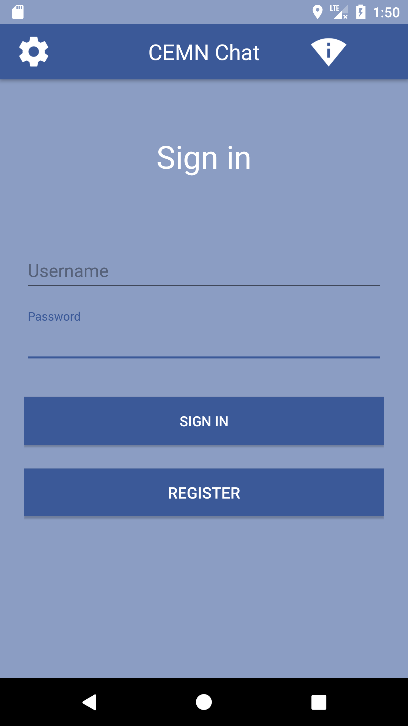

Registration Activity

The Registration screen has a text field for a user name, two text fields to enter the pass word twice for validation, a button to register the user name and pass word with a registration server and a cancel button to clear all the fields.

The Registration screen asks the user to enter a user name and a password (twice to ensure that they match). Each letter of the pass word appears for a second and then is obscured to ensure privacy.
When the user presses the REGISTER key the user name and pass word are encrypted and stored in a secret location on the Android phone using shared preferences. The App also generates a 2048-bit RSA Private and Public Key using the Android Crypto library functions.
The user name, Password and the corresponding Public Key are then send to the Registration Server. The registration server confirms that the user name is available and not already used. The public key and the user name uniquely identify the user to the Registration and Message Server. The Password is sent as an AES-128 encrypted string.
Each user must sign in using their Password. In developing countries, a single family may be sharing phone so multiple users are possible.

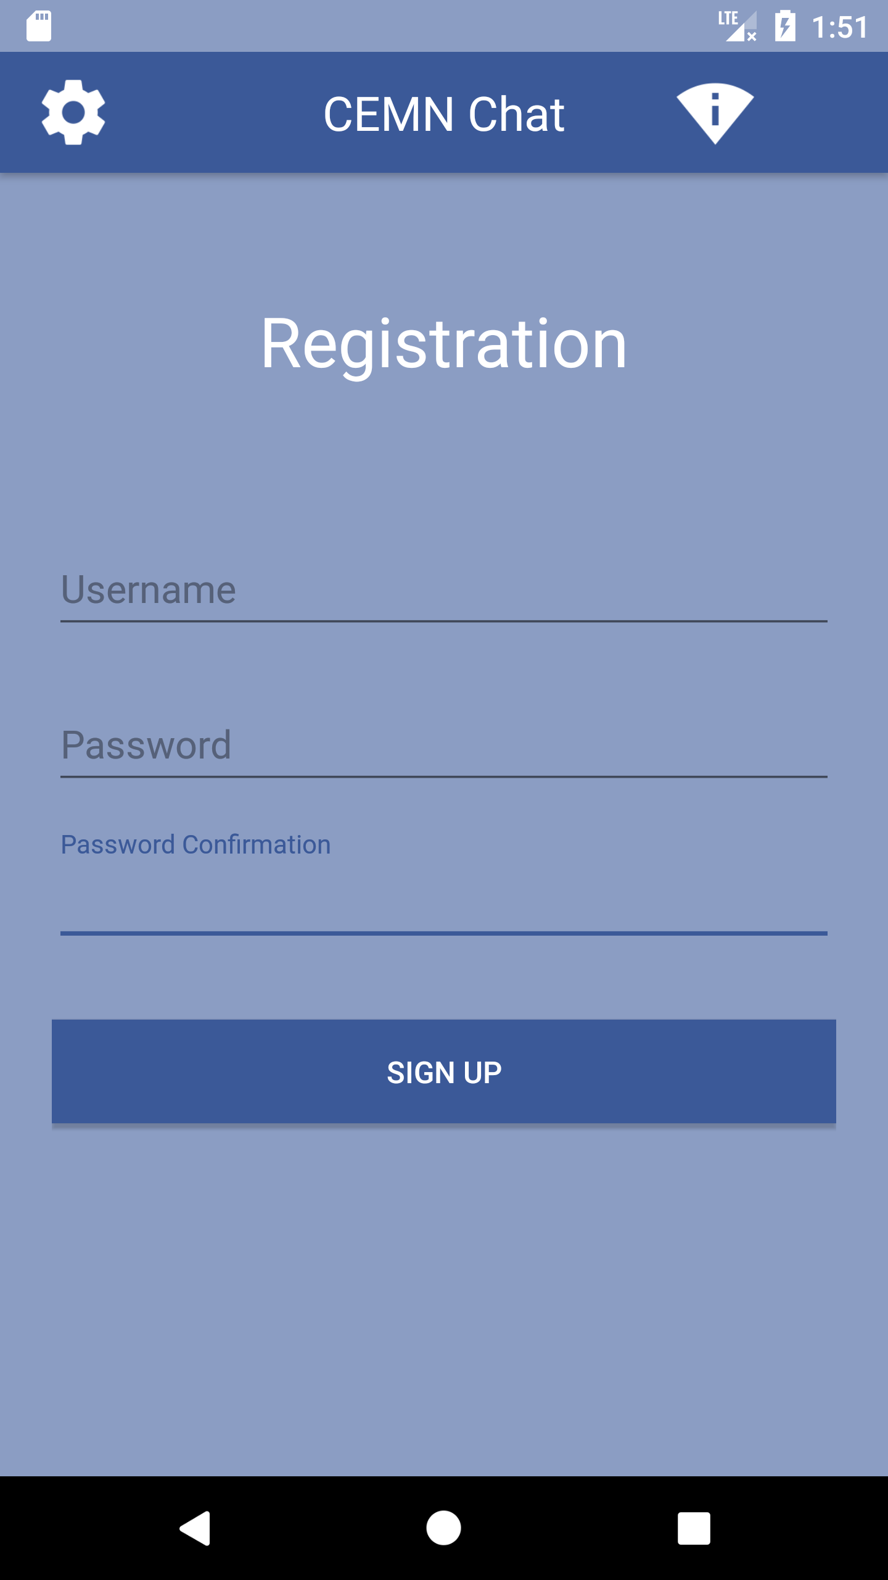

Contact Activity

The contact activity screen of the App has a title bar across the top with a GEAR icon in the upper left-hand corner of the screen to access the STETTING menu for the App, the title “CEMN CHAT” in the middle of the title bar, an icon showing the status of the WiFi to the right of the title and then an “X” icon in the upper right corner to indicate a way to exit the program.
Below the title bar is a text edit field to enter the name of a recipient. To the left of the text field is an icon of a HEAD to indicate access to a CONTACT list.
There is a CONNECT button that can be used to find the recipient user through their username and start the chat. The registration server starts searching for the recipient username entered in text edit field once the user hits CONNECT button and opens the Chat Activity if recipient username exists.

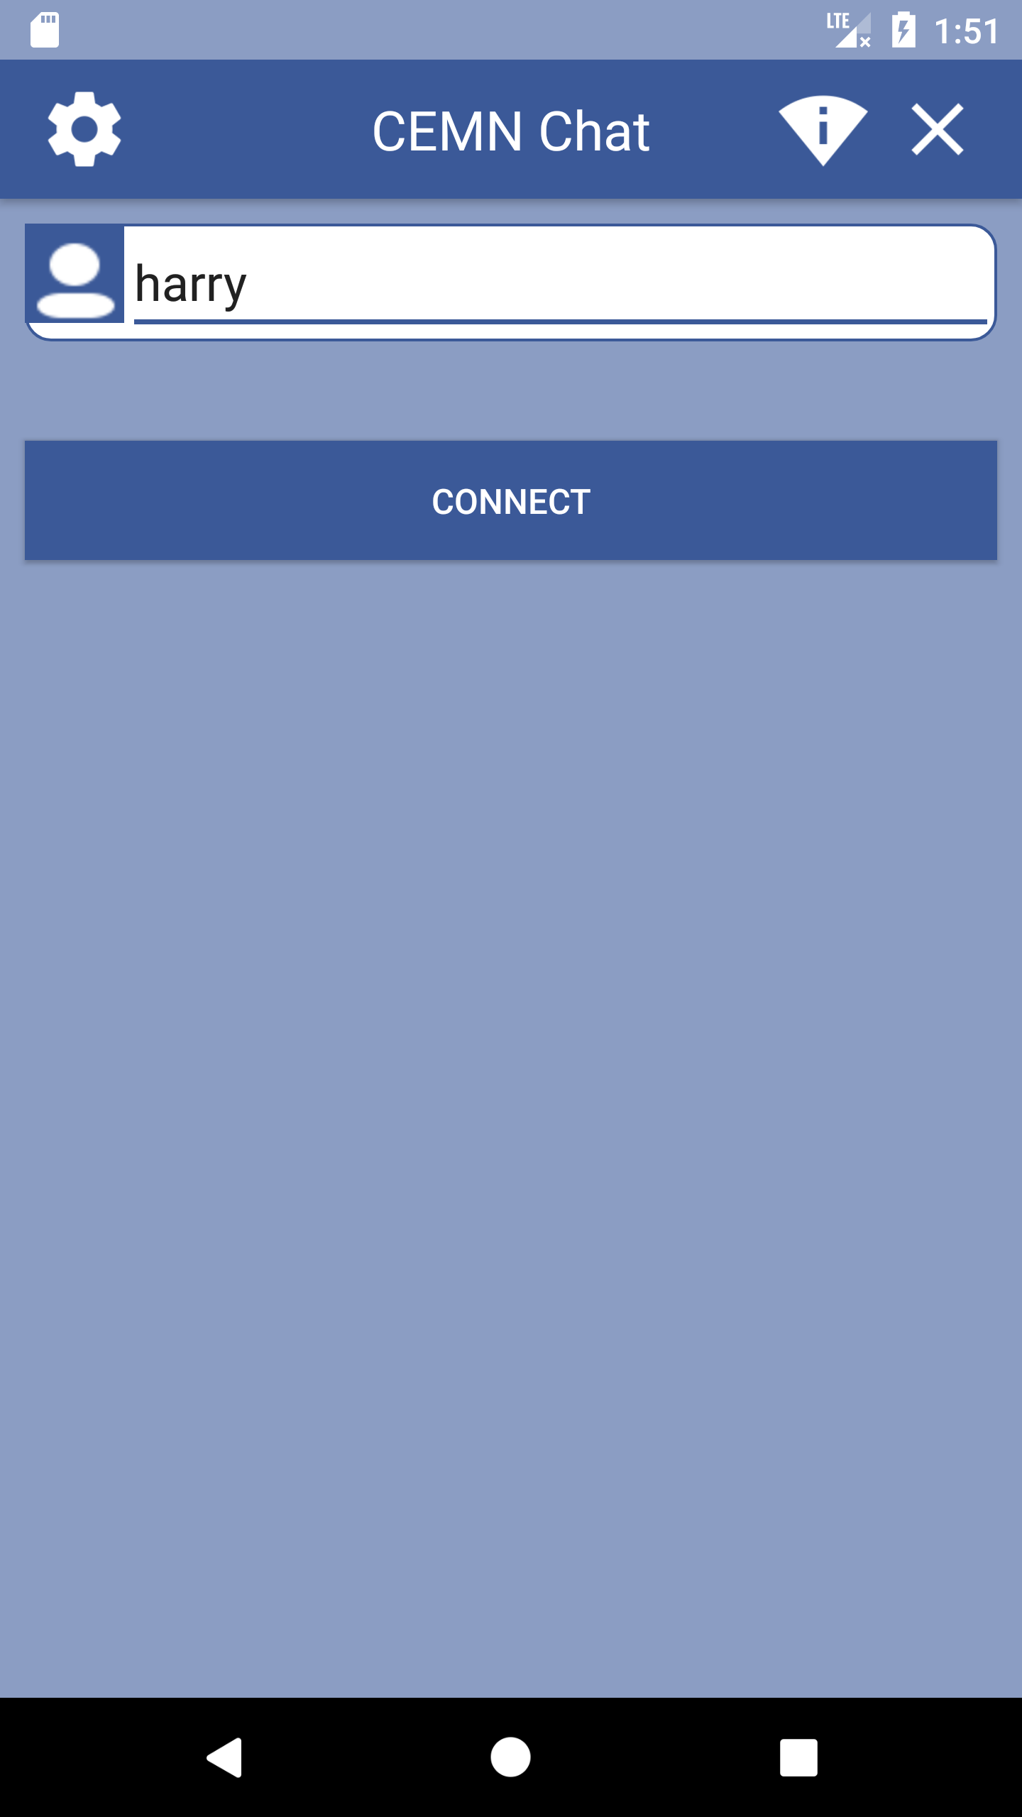

Main Chat Activity

The chat activity screen of the App has a title bar across the top with a GEAR icon in the upper left-hand corner of the screen to access the STETTING menu for the App, the title “CEMN CHAT” in the middle of the title bar, an icon showing the status of the WiFi to the right of the title and then an “X” icon in the upper right corner to indicate a way to exit the program.
At the bottom of chat activity screen is a multi-line text field. The user can enter a text message in this field. Pressing enter sends the message to the message server located on the network. The sent message is encrypted using the RSA 2048 method. Each message is assigned a unique ID by the CEMN App that will be used in the acknowledgement message sent back from the Recipient’s copy of the CEMN App. The message is also signed with a digital signature. The Hash of the text message is calculated using SHA-256. The Hash is then encrypted using the user’s private key and RSA-2048. That digital signature is added to the XML documents that forms the message. How the signature is verified is describe below in the receiving message process.

The field also displays any incoming message. Incoming message are also encrypted using the RSA 2048 method. First the digital signature is extracted from the XML document that forms the message. The Public Key for the sender is then used to decode the Digital Signature. The decoded digital signature should be the same of the Hash as the message calculated once it has been decrypted. The message first needs to be decoded using the locally stored user’s Private Key and RSA-2048 encryption. The Hash of the decoded text of the message is then calculated using SHA-256. The Hash from the decoded digital signature is then compared against the Hash calculated from the text of the message. If the two values are the same the message come from the sender’s who Public Key is associated with the User Name. The text of the message is then safe to display in the App edit text box. If the signatures do not match the user will be notified and the text in the message will not be show and the buffer purged of the text. Incoming and outgoing message should be displayed in a different color or reverse video to clearly indicate what is being received and what is being sent. (NOTE: Conversations on the phone are not persistent like SMS messages. Only the less few lines of the conversation are displayed on the screen and once the App is closed down or the phone re-started the conversation text is lost. This is to ensure there is no record of the conversation on the phone. User should be able to do screen shoot if they need to preserve a copy of any text on the screen.) The messages can also be setup to intentional disappear in 24 hours or some set time period.

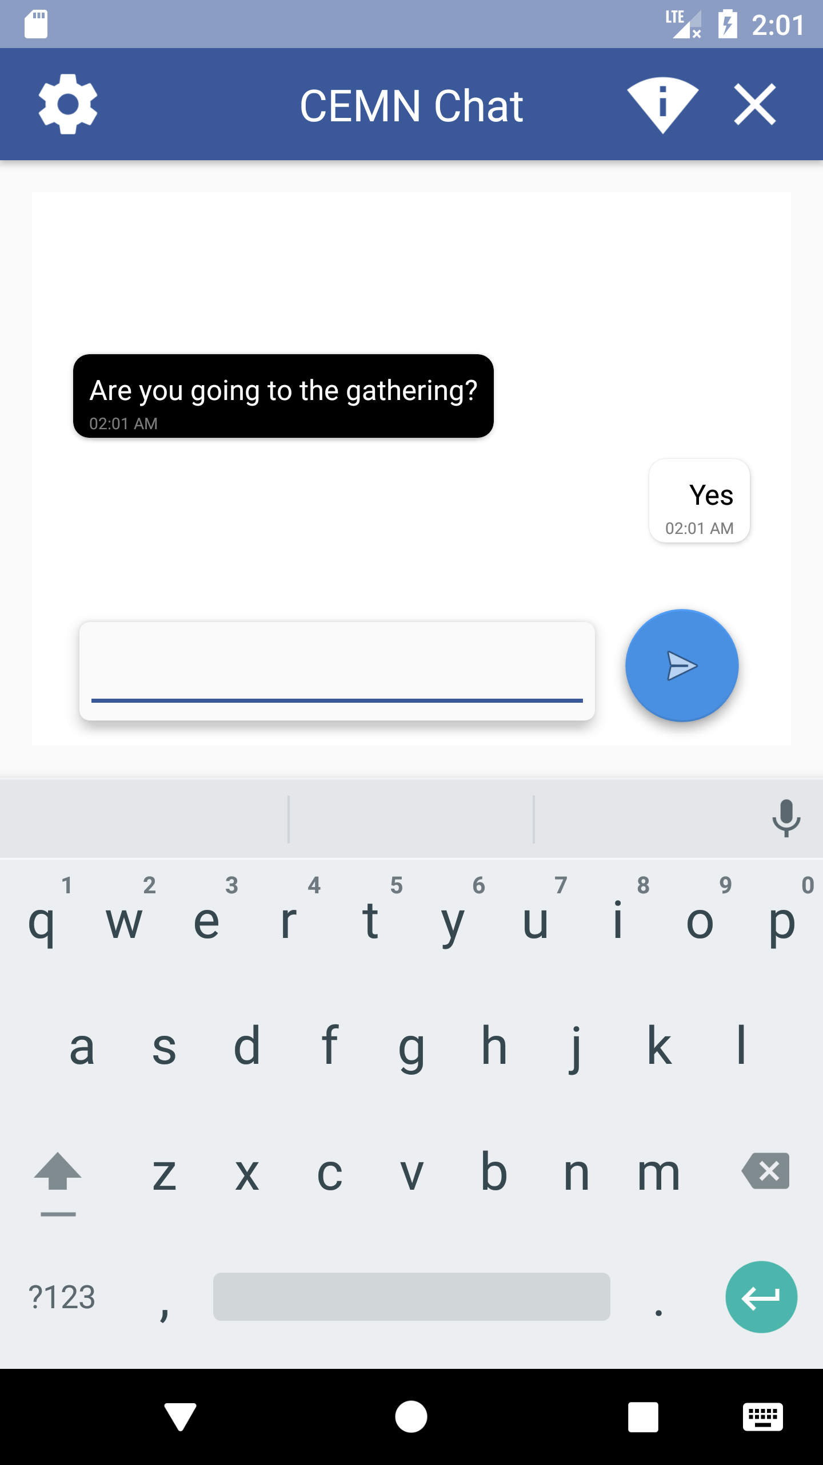

Contact list Activity

This section is currently under development and will be added.
When the CONTACT icon is hit a new CONTACT activity window appears.
The activity window contains a list of the existing contacts on the phone. The user can scroll through the list using a scroll bar on the right of the list box. They can highlight a contact by touching the appropriate name on the list.
To select the highlight name the user need to hit the SELECT button below the list box. This ensure the user need to confirm the recipient. The alternative is to select the name once you touch the name. On phones with small screens this means a wrong name may be selected and they will have to hit the CONTACT icon again and start the process again.
When the SELECT button is hit the CONTACT dialog box is dismissed and the information transferred to the text edit field on the previous screen for the recipient.
Next to the SELECT icon is an ADD icon. Hitting the ADD icon brings up a DIALOG box to enter the name of a new contact.
The ADD CONTACT dialog has a single line text field to enter a new contact user name and a ADD button and a CANCEL button. Hitting ADD adds the user name to contact list and dismisses the dialog. Hitting CANCEL dismisses the dialog box.
When the ADD button is hit the user name of the contact the user is trying to add is sent to the Registration Server. The Registration Server confirm the user name exists in the database and send back the Public Key association with that user name back the user’s App. The Public Key is then stored with the User Name in a Key Store on the device.

Settings Activity

This section currently only contains a REGISTRATION and a CHANGE password and username choices but more options will be coming. Password protecting the contact list might be one other option.
The REGISTRATION button or checkbox item allows the user to register addition users for this App. This is designed to support a family or group of family. That allows the recipient to know who is sending them the message.
PASSWORD allows a user to change their existing pass word stored on the Registration Server. They need to confirm their existing PASS WORD before the Registration Server will allow them to change their existing pass word.
Selecting PASSWORD brings up a dialog with the following text field for the user name, old pass word and two fields for the new pass word in order to validate it and an CHANGE and CANCEL button. Hitting CHANGE button sends a change request to the Registration Server. Hitting CANCEL dismisses the dialog. If the change is successful a box comes up letting the user know the change was successful otherwise a box comes up with the appropriate error message.
A similar dialog comes up when the user selects the change USER NAME. The text fields are USER NAME, NEW USER NAME and pass word. There is a CHANGE and CANCEL button. Selecting CHANGE sends the request to the Registration Server. Selecting CANCEL dismisses the dialog.

The above features are already implemented in the original implementation of the CEMN design for underserved communities in underdeveloped countries. A number of additional feature need to be added to make the App more usable for the end user and to help facilitate efficient usage off the network bandwidth. The application should be able to access the contact list of the user when the application is loaded. Users need to register with a user name to use the message server. In order to send a message to a recipient the sender must know the user name the recipient is using. In aftermath of a disaster it is difficult to let contacts know what your user name is. It is easier to register user using their phone number. By access the existing contact list, the application can display the user’s name from the contact list but actually send the message to a user name this is defined by a phone number in the registration server and message server. The user of the application need to see the recipient’s name because in this day and age very few people remember phone numbers anymore and very few people carry phone books. All that information is not contain in contact list on phones.

The second new feature is the application on the phone needs to synchronize with the scheduler in the message server node. Because bandwidth is in limited supply on the network, when a user tries to send a message or series of messages or request a message they need to schedule a time slot to send or receive a messages from the message server. Rather than tie a session on an access node the application should terminate its session and then create a new session when it allotted time slot to send or receive a message comes up. There are a limited number of simultaneous session that are possible per radio in a node. In the initial design the designers have modelled one radio per node for the access point. That means there is a maximum of 250 simultaneous sessions available per access node at any one time. 1000 message request would therefore take 4 seconds to process assuming it takes one second to initiate the message request by a user. Depending on the population density in a location the designers have number that indicate typical cellular tower can supports 250 to 35,000 simultaneous session depend on the number of radios installed in tower and the technology used (TDMA, GSM, LTE etc …). Using 35,000 at the first order approximation for typical density it would take 140 seconds to schedule 35,000 message requests.

Basics of Privacy and Encryption

Privacy and authentication is important to everyone but especially in a disaster situation when trusted sources of information are important. As a result it is important to briefly explain a number of basic cryptography terms and principle to explain the need for and the implementation method for each cryptographic technique.

Hashing is a method of converting a string to a series of numbers of a fixed length. The process a complex and is intended to be work only in one direction as the process can not be reverse to recover the original string. If constructed properly a unique string will only produce a unique series of numbers. Hashing is typical used to encrypt data that does not have to be decoded again. By comparing the output of a hash function data can be verified. A good example of this would in the verification of pass words.
It is insecure to store the pass words in a database in case the security of the database is broken. If the actual strings that make up the pass word is stored in the database once the security is broke one could simple read the pass word strings out of the database. It is more secure to store the results of a hashing function in the database. When the user enters their pass word, the string for the password is passed though the same hashing function and the result and compared with the previously stored result in the database.

Symmetric Encryption

In Symmetric Encryption a mathematic algorithm is used to encrypt the information and the reverse of that algorithm is used to decode the encrypted information. The encryption technique is known to be symmetric as the reverse technique is used to decode it. A simple example of a symmetric encryption technique is a simple letter replacement cipher. Each letter of the alphabet is replaced by another letter in the alphabet. Usually a key, an agree upon series of letters and numbers is used to decode the message. For the replacement cipher the legend details what letter was replace with which letter. In more advanced symmetric algorithms the key is made up of a long series of letters and numbers. The sender and the recipient of the encode message must protect the key as anyone can decode the message if they have the key. Typically, when a message is sent through the internet the key is sent by mail or by phone conversation to preserve the secrecy of the key.

Asymmetric Encryption

In Asymmetric Encryption each user of the system generates a Public and Private Key. The keys are simply large numbers that have been paired together but are not identical (asymmetric). The user’s Public Key is then shared freely among their friends. When a friend wants to send that user a message they combine the Public Key and the text of their message and run it through the encryption algorithm. The output is typically a series of scrambled letters and numbers. The friend can then send the message to the recipient using standard email or text messaging methods. Anyone can intercept the message but a recipient can only decode the message if they have the Private Key. Technically either of the keys can be used to encrypt a message; the opposite key from the one used to encrypt the message is used for decryption. The encryption method is sophisticated enough that it would take years using a super computer to try all the potential variations that could break the code. Encryption techniques that use 2048 bits or more are currently considered the most secure though 1024 bit is still considered adequate. 1024-bit encryption for example is used to secure many internet bank transactions. As computer power increases the number of bits required to be secure increases. No mathematical encryption algorithm is considered totally secure. Given enough time any code can be broken. In terms of the most sophisticated algorithms the time to break the code can be measured in decades so they are considered reasonably secure.

“Many protocols like SSH, OpenPGP, S/MIME, and SSL/TLS rely on asymmetric cryptography for encryption and digital signature functions. It is also used in software programs, such as browsers, which need to establish a secure connection over an insecure network like the internet or need to validate a digital signature. Encryption strength is directly tied to key size and doubling key length delivers an exponential increase in strength, although it does impair performance.”

“RSA (Rivest-Shamir-Adleman), the most widely used asymmetric algorithm, is embedded in the SSL/TLS protocol which is used to provide communications security over a computer network. RSA derives its security from the computational difficulty of factoring large integers that are the product of two large prime numbers. Multiplying two large primes is easy, but the difficulty of determining the original numbers from the total -- factoring -- forms the basis of public key cryptography security. The time it takes to factor the product of two sufficiently large primes is considered to be beyond the capabilities of most attackers, excluding nation state actors who may have access to sufficient computing power. RSA keys are typically 1024- or 2048-bits long, but experts believe that 1024-bit keys could be broken in the near future, which is why government and industry are moving to a minimum key length of 2048-bits.”

Authentication

Beyond privacy of the message it is important to ensure the message comes from someone you trust and it is from who they say they are. Digital signatures are used to ensure the message came for the person who they say they are.

“Digital signatures are based on asymmetric cryptography and can provide assurances of evidence to origin, identity and status of an electronic document, transaction or message, as well as acknowledging informed consent by the signer. To create a digital signature, signing software (such as an email program) creates a one-way hash of the electronic data to be signed. The user's private key is then used to encrypt the hash, returning a value that is unique to the hashed data. The encrypted hash, along with other information such as the hashing algorithm, forms the digital signature. Any change in the data, even to a single bit, results in a different hash value. This attribute enables others to validate the integrity of the data by using the signer's public key to decrypt the hash. If the decrypted hash matches a second computed hash of the same data, it proves that the data hasn't changed since it was signed. If the two hashes don't match, the data has either been tampered with in some way (indicating a failure of integrity) or the signature was created with a private key that doesn't correspond to the public key presented by the signer (indicating a failure of authentication).”

A digital signature also makes it difficult for the signing party to deny having signed something. This is known as Non-repudiation.

“Digital signatures are typically made in a two-step process. The first step is to use a secure hashing algorithm on the data. SHA-2 algorithms would be an example of that. The second step is to encrypt the resulting output with the private signing key.

Thus, when a signature is verified by the public key, it decrypts to a hash matching the message. That hash can only be decrypted using the public key if it were encrypted with the private signing key. “

Implementation of Privacy and Authentication

Certain aspects of the system design that affect privacy and authentication are distributed and other aspects are centralized and hosted on servers attached to the mesh network. Generation of the asymmetric keys are accomplished in the copies of the CEMN custom application installed on the mobile devices. Publication of the public keys that are necessary to identify a recipient are done on a Registration Server hosted on a node on the mesh network. Interactions with the Registration Server are encrypted using a symmetry encryption scheme and signed to ensure that hackers can not modify or re-direction the transmission of messages.

Messages sent through the mesh network are handled by an XMPP (Extensible Messaging and Presence Protocol) Message Server hosted on a server connected to one of the nodes in the mesh network. XMPP is a client-server architecture. Messages are relayed through a server. The client pushes messages on to the server and is responsible for polling the server to find out if any new messages are available for the recipient. When an XMPP server is connected to the World Wide Web and able to access addresses outside of the mesh network it is possible to add the extras security of using TLS (Transport Layer Security) and SSL (Secure Sockets Layer) encrypted channels. TLS and SSL typically require access to a third party trusted source that will validate the SSL certificate of the website the user is trying to visit and then set up the TLS/SSL secured transmission channel. Registration of an SSL certificate with a trusted source usually involves paying a recurring fee. In isolated regional networks that can not access the greater World Wide Web access to third party trusted sources for SSL certificate validation is not possible. While it is possible to use Self Signed SSL certificates there is not way to completely validate the authenticity of this kind of certificate.

The XMPP Server implementation was chosen as it simplifies the formatting of the messages which are typically broken down into smaller packets and then transmitted over the network. The XMPP Server handles temporarily storing and forwarding the message on to the recipient. The XMPP Server and Client software is open source and is a mature technology. Variations of XMPP technology are implemented in programs such as WhatsApp, Yahoo Messenger, Facebook Messenger and early versions of Google Chat

As it is not possible to use TLS or SSL encrypted transmission channels the text in the messages will be encrypted using an asymmetric encryption algorithm. For extra safety many email clients/apps offer encryption of the text of the email on top of the TLS/SSL encryption channel communications provided. Pretty Good Privacy (PGP) encryption is one popular open source email encryption technique. An open source version of PGP call GNUPG exists. The PGP encryption process is complex to understand and the specification provides for many services that are not necessary for basic secure communications. The designers want to make the system simple enough that it could be modified without having an extensive knowledge of encryption without sacrificing privacy and security of the message transmission. So, the choice was made to use a simpler but secure encryption mechanism for the text content of each message. It should also be noted that some countries have regulations that prohibit the importation of technology that encrypts communications. While the designers make no declaration on whether the system compiles with the regional regulation, it does note that the design is open source and therefore can be modified to meet the needs of the end user.

The client (Messaging App) for this system design was written for the devices that use the Android operating system. The Android operating system has the largest installed base across a range of phones in different price points. The Apple IOS system while popular in developed country is quite expensive and unaffordable for many end users in developing countries. While the client was written with Android operating system in mind it can be ported to other systems. The designers have tried to reduce system complexity while maintaining key features that are critical to end users – low cost, availability, authentication and privacy.

As a result, the system is using the Android Cryptography APIs provide through Android studio, A combination of symmetric and asymmetric keys and hashing functions are used in the design of the client software. In addition, the Android API used to securely store keys are used to store private and symmetric keys on the actual handset. Physical access to the handset is necessary to access the keys. Many of these cryptographic API has existed since the first early releases of Android so older phone will be compatible with the CEMN Application.

“ The most widely-used algorithm used in symmetric key cryptography is AES (Advanced Encryption Standard). It comprises three block ciphers, AES-128, AES-192 and AES-256, each of which is deemed sufficient to protect government classified information up to the SECRET level with TOP SECRET information requiring either 192 or 256 key lengths. Other common symmetric encryption algorithms include Blowfish, Twofish, Data Encryption Standard (DES), 3DES and RC4, although recent attacks have revealed weaknesses in the RC4 algorithm.”

The main disadvantage of symmetric key cryptography is that all parties involved have to exchange the key used to encrypt the data before they can decrypt it. In small isolated network such as the CEMN network where aspects of the design are pre-determined the keys can be build into the clients and servers ahead of time. While the current design is totally open source to demonstrate the concepts, an actual implementation would change the symmetric encryption method and keeping it the keys secret. This system design will use AES-128 for all symmetric encryption.

“One of the most common asymmetric encryption algorithms is the Diffie-Hellman key exchange, which allows two parties to exchange cryptographic keys in a secure manner regardless of whether the communication channel is public or private. The RSA (Rivest, Shamir and Adleman) asymmetric algorithm is another widely used asymmetric encryption example; it is often used in electronic commerce protocols such as SSL, and is believed to be secure given sufficiently long keys and the use of up-to-date implementations.”

RSA 2048 is used for all asymmetric encryption in this system design. The Android Cryptographic API supports generating RSA 2048 public and private keys and provides methods to encrypt and decode messages using RSA 2048. Note that RSA has a limitation of 117 bytes of data that can be encrypted for RSA 1024 and 200 bytes of data for RSA 2048. RSA is typically not used to send large blocks of data. For large blocks of data the data is encrypted using a symmetric key and then the encrypted block of data is sent with the symmetric key encoded in RSA 1024 or RSA 2048 to the recipient. The recipient decodes the asymmetrically encoded symmetric key and then uses the decoded symmetric key to decode the large block of symmetrically encoded data. A new symmetric key is generated each time a block of data is transmitted from the sender to the recipient. The designers of this project have decided to the keep the user experience of the SMS system which has a character limit of 140 bytes. The 140 bytes is due to the fact the SMS messages are transferred in the frames for the control commands for the network traffic when there is idle time in the transmission of command codes. SMS is not guaranteed to delivered in a timey manner as a result because the control codes take precedent. Depending on the amount of traffic a SMS message can be delay minute or hours if there are a large number of messages and a large number of network control codes that need to be transmitted.

“MD5 and SHA-1 were widely used hash algorithms, but are now considered weak and are being replaced by SHA-224, SHA-256, SHA-384 or SHA-512, sometimes collectively referred to as SHA-2. Microsoft, Google and Mozilla have all announced plans to remove SHA-1 support from their browser products. Although no attacks have yet been reported on the SHA-2 variants, they are algorithmically similar to SHA-1 and so a new hash standard, SHA-3, will be selected in a similar way to AES in the next few years.”

All hashing will be done using SHA-256 in this design.

[Note: Where possible all encryption has been done using open source tools and libraries. Even though the tools are freely available it is important to note that some jurisdictions prohibit encrypted communications and other jurisdictions prohibit the importation or export of encryption methods that can not be easily broken. The designers make no claim on the appropriateness of the encryption used in this design in regards to deployment in specific jurisdictions. Users deploying the system should comply with the local regulation. The designers are not security researchers so no explicit claims are being made of the absolute security of the encryption methods and the integrity of the system. The designers have tried to highlight the key privacy and security issues and implement methods to address those issues. Determined hackers can break any system given enough time and resources. This design attempts to put in place measures that can be implemented easily with minimal encryption and cyber-security knowledge. The designers have drawn from the best practices from existing more sophisticate systems and protocols in this design.]

“A digital signature in its simplest description is a hash (SHA1, MD5, etc.) of the data (file, message, etc.) that is subsequently encrypted with the signer's private key. Since that is something only the signer has (or should have) that is where the trust comes from. EVERYONE has (or should have) access to the signer's public key. So, to validate a digital signature, the recipient (1) calculates a hash of the same data (file, message, etc.), (2) decrypts the digital signature using the sender's PUBLIC key, and (3) compares the 2 hash values. If they match, the signature is considered valid. If they don't match, it either means that a different key was used to sign it, or that the data has been altered (either intentionally or unintentionally).”

All hashing for digital signatures will be done using SHA-256 in this design.

Implementation Details of the Chat User Client

Registration USER NAME, PASS WORD and unique ID returned from the Registration Server is Encrypted using AES-256

Outgoing messages to the Message Server are encrypted and decoded using RSA-2048 and incoming messages from the Message Server to the client App are similarly encrypted and decoded using RSA-2048

The USER NAME and the PASS WORD are used provide Authentication of users. It prevents users form pretending they are some else so that they can send and receive message intended for someone else.

Encryption

The client (Messaging App) for this system design was written for the devices that use the Android operating system. The Android operating system has the largest installed base across a range of phones in different price points. The Apple IOS system while popular in developed country is quite expensive and unaffordable for many end users in developing countries. When client was written with Android operating system in mind it can be ported to other systems. The designers have tried to reduce system complexity while maintaining key features that are critical to end users – low cost, availability and privacy.

As a result, the system is using the Android Cryptography APIs provide through Android studio, A combination of symmetric and asymmetric keys are using in the design of the client software. In addition, the Android API used to securely store keys are used to store private and symmetric keys on the actual handset. Physical access to the handset is necessary to access keys.

It is important to briefly explain an number of basic cryptography terms and principle to explain the need for and the implementation method for each cryptographic technique. The most important terms are:

Hashing
Symmetric Key Encryption
Asymmetric Key Encryption

“Encrypting: encryption transforms the plaintext into something that cannot be understood - something that doesn't have any meaning. Something unintelligible. You encrypt the message/plaintext by using an algorithm and a key. The output (the ciphertext) always depends on the key. The essential thing about encryption is that you can always recover the plaintext (if you know the key/password), and given a key/password you have only one plaintext. So, you can think of encryption/decryption as a way to move back and forward between you plaintext and your cipher text (using a key).
Uses: Encryption is good if you say have a message to send to someone. You encrypt the message with a key and the recipient decrypts with the same (or maybe even a different) key to get back the original message.

Hashing: hashing turns something (usually a key or a password) into a (usually fixed length) string of characters. For example, your hashing algorithm might always produce a string that is 8 bytes long. As with encryption you transform something intelligible into something unintelligible. One might call the product of the hashing the hash codes of the hash sums. One difference is that hashing two different messages might produce the same hash values. So, you cannot decrypt something that you have hashed. But even though you can't decrypt a hashed value, it is (or it should) in general hard to make two messages that have the same hash value. Another difference is that hashing doesn't require a key.
Uses: One use of hashing is if you want to send someone a file. But you are afraid that someone else might intercept the file and change it. So a way that the recipient can make sure that it is the right file is if you post the hash value publicly. That way the recipient can compute the hash value of the file received and check that it matches the hash value.”

Note that HAM Radio protocols prohibit the use of encryption in data traffic send over the HAM radio frequency. In implementation that use HAM radio protocols to transfer data the encryption must be disabled. The data rates of the HAM protocols are typically low (500 kilobits per second or less), the increase power allowed for the transmitters may help in certain situation where increase range of the transmissions is important.

Overview of the Mesh Network

The mesh network architecture is made up of 4 component parts:

Hot spot software
Mesh network software
Registration Server
Message Server (XMPP)

Each component part is essentially independent of the other component parts. The connection between them is the physical link provided by the WiFi connection between the nodes.

The hot spot software runs on each one of the nodes. This software facilitates the handset connecting to the network and handles the sending and receiving packets of data. The data is bridged to the mesh network software which is used to access the mesh network. Hot Spots are local to the node and have a maximum range of 30 meters and they use a Omin-directional antenna.

The mesh network software runs on each of the WiFi nodes. The software handles the routing of packets between the nodes and picks the best path of sending packets to a specific node or to all the nodes and handles re-routing if a node goes down or is temporarily unavailable. The nodes have unique IP address.

The Registration server is connected to one of the WiFi nodes and essentially has its own unique IP address. In it simplest implementation there is only one registration for the whole network. In an ideal world there should be back up Registration Server in case the primary Registration Server goes down. The Registration Servers should sync at least once every 24 hours. For simplicity the client App know the number of registration servers for the network. The App sends requests to the primary Registration Server. If it does not receive an answer in a fixed period of time it then switches to the secondary Registration Server. The changes made on the primary and secondary and any additional servers between sync period are time stamped. When the Registration sync they compare the time stamps of the changes before syncing the list of changes on both servers. This is necessary as network congestion or problems can shut down access to the primary Registration Server for a short period of time. In that case new registration or changes to existing registration could be made on the secondary server. Combining the changes on all servers are necessary to retain a complete list of changes.

The Registration Server works with the Message Server to resolve the USER NAMES into the unique ID registered to each USER NAME. This is done to make sure users are anonymous. Physical access to the registration server and access to the encryption key for the data on that server are necessary to resolve the IDs. Even then IDs are assign randomly so the Registration Server has no idea of the actual identity of the owner of the handset.

The Message Server receives all the encrypted messages sent by the registered handsets on the network. The Message Server talks to the Registration Server to resolve the USER NAME of the recipient embedded the message to its unique ID. It also confirmed that the encrypted PASS WORD for the SENDER of message matches the USER NAME.

The application on the handset periodically queries the message server to see if any messages are available for the user in its queue. If a message is available the scheduler schedules a time slot for the application to pull the messages from the queue. When the time slot comes up the application signed into the message server using it unique pass word and then pulls the messages from the queue for the recipient. The system is designed to passive in nature the application on the handset has to active request to have access to the message for the recipient in its queue.

When a message is successfully received the handset App send back an encrypted acknowledgement to the Message Server intended for the original sender. The App on the Sender’s handset will keep trying to send a message every “X” minutes (suggest 120 minutes in an emergency situation to ease network traffic) till it receives an acknowledgement. If it does not receive an acknowledge after 24 hours the message is lost and the handset will stop trying and the user will be notified of the failure.

The recipient’s handset will have a record of the last 50 messages. It will match incoming message with message in the buffer. It will re-send the acknowledgement of the message but it will not display a duplicate message to the user of the recipient handset again.

Connecting the handset to the WiFi hotspot

In its simplest implementation the user is responsible for connecting to a hot spot when they want to send or receive messages. The text messaging feature is always on but relies on being close to a tower that provides cellular service. When you are outside of the coverage of the cellular towers service is not available. Depending on the deployment density of the towers of the mesh network this may or may not also be possible.

In an ideal scenario the App would be able to detect nodes in the mesh network and automatically connect to the one with the strongest signal strength. Each node would have an unique identifier with a set of digits in the unique identifier that define a range of nodes (for example - 0 to 32768) . The App would know the potential range of unique identifiers so it would not connect to WiFi nodes that are not part of the mesh network. It is not necessary to hide the IDs for each of the nodes. The mesh network essentially operates as an open network. As there is not necessarily access to the internet connectivity outside of the network and the network is purpose built for the message application there should be no reason to have restricted access. In order to make usage easy no pass word is required to connect to the network.

As specified above the application is designed to sign on to the network only for a brief period of time in order to communicate with the scheduler to setup a time slot to send or receive messages or to actually send or receive messages when the allocated time slot comes up. This done to most efficient utilize the limited number of simultaneous session available at each access point node (typically 250 per radio) and the limit the overall traffic on the network. The application establishes a session makes the appropriate request of the scheduler or server and then terminates the session. The message itself is larger in size than a request to the scheduler and the biggest size for a message is 32 kilobits.

Implementation of Details of Mesh Network

The actual hardware implementation of the mesh network has the following requirements:

- Be robust so that it can tolerate abuse and long periods in isolated outside environments
- Be easy to setup
- Not require access to a consistent and reliable source of power
- Have the software and firmware be updated and maintained remotely in as many use cases as possible

Overall System Architecture Implementation Details

The overall system Architecture can be divided to 5 main components:

Access point/mesh Network
Scheduler servers
Load balancer servers
XMPP ejabberd messaging servers
Registration servers

The following diagrams shows the overview of the system:

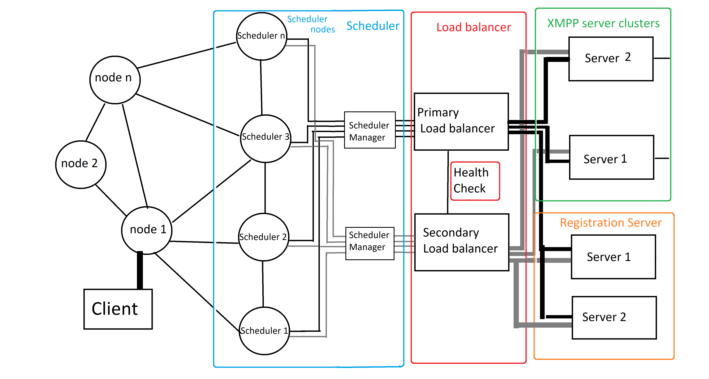
The full instruction on how to setup the mesh network, scheduler server, load balancing server, and messaging server are available in Appendix A which can be divided as following:

Download and install the necessary software and packages which applies to all the nodes
Download and install the code for Registration server node which only applies to Registration server node
Download and install sleekxmpp in main and secondary scheduler server
Download and install HAProxy load balancer in main and secondary load balancer server
Download, Install and configure XMPP which only applies to XMPP or messaging node
Setup batman-adv mesh network which applies to all the nodes
Setup Access point and bridge Access point with batman-adv mesh in each node and the setup instruction applies to all the nodes. The static IP and name of each Access point should be different in each node.
Instructions to test and make sure that each node has been setup successfully

Mesh Network Implementation Details

The mesh network and messaging system are being implemented on Raspberry PI 3 single board computers. Raspberry PI 3 the system is capable of supporting WiFi through its internal WiFi transceiver or through a USB WiFi Dongles. The Raspberry PI 3 B was chosen for this designing the nodes as it is an older, well establish design that have fallen in price ($30) as the newer models of the Raspberry PI have been released. Each node must be capable of handling the local requests from users around the access point provided by the node plus the traffic from other nodes trying to route messages to the Message Server and information requests to the Registration Server.

The complete instructions on how to setup Raspberry Pi 3 can be found in official Raspberry Pi website site and following link:

https://www.raspberrypi.org/help/noobs-setup/2/

The instruction is written based on Raspbian Jessie OS version 2017-06-21-raspbian-jessie and is recommended to be used for the installation of each CEMN mesh node.

Raspbian Jessie OS version 2017-06-21-raspbian-jessie can be downloaded from following link:

http://downloads.raspberrypi.org/raspbian/archive/

The full instruction on how to setup the nodes are available in Appendix A.

Communication Radio Details

The wireless connection capabilities of the nodes are implemented using the LimeSDR Software-defined-radio (SDR) boards. Software defined radios allow the deploying organization to setup the system and the individual nodes to support the carrier frequencies and standardized wireless protocols that provide the appropriate range and performance required for their specific implementation. If deployed by a carrier and the nodes are being used to fill in gaps in its existing network the Software Defined Radio (SDR) stack could be configure to the support the carrier frequencies and modulation scheme of the specific LTE implementation compatible with its existing network. Similarly a smaller community can use a complete WiFi based system to achieve the coverage required for their community as WiFi does not require a specific license from the FCC to be deployed. Intermediate and large size communities that cover diverse geographic and man made obstacles that make line of sight communication difficult must either deploy more tightly cluster nodes to go around the obstacle or may use frequencies that are appropriate to bouncing off the ionosphere to get more range such a bands allocated to HAM radio operators. Each technology has it is limitation but by using SDR it is possible to create a hybrid system that can over come the challenges of connecting nodes over longer distance and more challenging geographic and man made obstacles.

The LimeSDR united allow designer to implement any protocol using software stacks. As a result it is possible to use the same hardware to support different protocols from WiFi, to LTE to HAM radio protocol all in one system. It also makes it easy to combine technologies to achieve specific system characteristics. WiFi for examples is more suited to intermediate bandwidth capacity at short to intermediate ranges. LTE is suited to providing high bandwidth from intermediate to long distances. HAM radio data protocol are suited to providing low bandwidth at intermediate to long distances. LimeSDR is an open source initiative that allows designer to provide various wireless protocol stacks as a service that can be easily swapped in and out depending on the system requirements.

Whether the technology is LTE, WiFi, HAM radio or a priority protocol each base station radio is only going to be able to support a limited number of simultaneous connections that are limited by the available bandwidth and the processing power to service each of the unique requests.
For comparison the following properties are associated with each technology:

Maximum uplink speed of LTE 50 megabits per second
Maximum downlink speed of LTE 100 megabits per second
Typical Power per base station 10 and 40 watts.

WiFi using 802.11 n can achieve 300 megabits per second theoretical if bonding is used (200 megabits per second nominal ) and 150 megabits per second otherwise (100 megabits per second nominal) The disparity between theoretical and practical Wi-Fi performance comes from network protocol overhead, radio interference, physical obstructions on the line of sight between devices, and the distance between devices.

Here's a Wi-Fi speed chart that compares the actual and theoretical speeds of a Wi-Fi network:
 | Theoretical | Actual
802.11b | 11 Mbps | 5.5 Mbps
802.11a | 54 Mbps | 20 Mbps
802.11g | 54 Mbps | 20 Mbps
802.11n | 300 Mbps | 100 Mbps
802.11ac | 7,000 Mbps | 2,100 Mbps

Note that depending on the chipsets in the radios the uplink and downlink speeds of WiFi may also not be symmetric.

“Since you do not need a license to operate a WiFi (IEEE 802.11)radio, the FCC regulates their power. The effective power of the radio with its cables and antenna must be under 1 watt if you use an Omni-directional antenna that radiates equally in all directions. The limit is increased to 4 watts if one uses a more focused antenna that is less likely to cause interference.
Since the antenna adds effective power, the radios themselves have a maximum power well under 1 watt. (With most WiFi chips, the driver software can control the power level).

WiFi manufacturers rate the power of their radios relative to a 1 milliwatt radio. So, for example, a 100 milliwatt radio is 100 times as powerful as the reference radio.”

The 33 cm ham/ISM band is also available for the transmission of data. The FaradayRF open source board implements a from of data transmission at that band using the 2 FSK transmission protocol. 2 FSK is essentially a binary from of frequency shift keying where one modulation frequency superimposed on the carrier is a ‘1’ and another modulation frequency is a ‘0’

“The 33-centimeter or 900 MHz band is a portion of the UHF radio spectrum internationally allocated to amateur radio on a secondary basis. It ranges from 902 to 928 MHz and is unique to ITU Region 2. It is primarily used for very local communications as opposed to bands lower in frequency. However, very high antennas with high gain have shown 33 centimeters can provide good long range communications almost equal to systems on lower frequencies such as the 70 centimeter band. The band is also used by industrial, scientific, and medical (ISM) equipment, as well as low powered unlicensed devices. Amateur stations must accept harmful interference caused by ISM users but may receive protection from unlicensed devices.”

The 33 centimeter band has a somewhat short history, being one of the newest amateur radio bands. The Radio Regulations of the International Telecommunication Union allow amateur radio operations in the frequency range from 902.0 to 928.0 MHz.

In 1985, the Federal Communications Commission allocated the frequency band between 902 and 928 MHz to Part 18 ISM (Industrial, Scientific, and Medical) devices. In that proceeding, the band was also allocated to the Amateur Radio Service on a secondary basis meaning amateurs could use the band as long as they accepted interference from and did not cause interference to primary users. Signal propagation on the 33 centimeter band is very dependent on the transmitting and receiving antenna's line of sight. Because of this, many wide-area coverage systems like repeaters are located on top of large hills and mountains which overlook a vast area. This ensures that the transmitting antenna is higher than terrestrial obstructions such as trees and buildings. Assuming that the transmitting antenna's wavelength, height above average terrain, and effective radiated power is equal, a transmitted signal on 33 centimeters will, generally speaking, usually travel about 3/4 of the distance that the same signal would if transmitted on the 70 centimeter band. Receiver front-end noise figure and antenna gain are the defining factors in line-of-sight signal propagation in the local area. The 33 centimeter band offers excellent building penetration characteristics since the wavelength is relatively small and can fit through windows more easily than signals lower in frequency.
In many areas, the 33 centimeter band also has a very low noise floor as compared to bands lower in frequency

There have been commercial network system base around the 33 cm band in the past.

“In the early 1990s, wireless computer networking was just becoming affordable. Several competing technologies emerged that made use of the 902-928 MHz Part 15 band, such as:

- NCR/AT&T/DEC/Lucent WaveLAN. 915 MHz, 250 mW transmit power. Obsolete, but still in use in certain areas.
- Aironet (now Cisco) ARLAN. 902-928 MHz with 12 channels, 450 mW transmit power. Obsolete, but still in use in certain areas.
- Alvarion BreezeACCESS 900. 902-928 MHz, 200 mW transmit power. Still being sold and in use in certain areas as of 2008.
- A now defunct commercial user of 900 MHz wireless networking was Ricochet. They used 900 MHz for the "last mile" connection to the user in an early wide area mobile wireless network.
- Motorola Canopy is also used by WISPs depending on the Line-of-sight propagation
- XG Technology, Inc. xMax. 902-928 MHz. Less than 1 W. A cognitive radio system still being sold and in use as of 2011.”

“Basically it is a radio designed to communicate digital data over the 33 cm ham/ISM band. The 33 cm band is between 902 to 928 MHz in the ITU Region 2 area (Americas, Canada, Greenland and some pacific islands). It was designed for amateur radio operators out of the need for a device that allows for easy experimentation with digital radio. An amateur radio licence is required, but only at the technician level which is the easiest licence to obtain.”

FCC Part 97.313 limits HAMs to 1500 Watts ERP (effective radiated power) for non-spread spectrum; and 10 watts for spread spectrum; using a 14 dBd gain antenna that would be almost 38000 WATTS non-spread spectrum and 412 watts spread spectrum. HAMs are REQUIRED to use the lowest amount of power necessary to carry out "reliable" communications. HAM radio communication also has the requirement that they data not be encrypted so if this protocol is used then any encrypted has to be turned off. In many case though the data rate is lower than the other protocols the effective range can be greater due to the higher allowed power of the transmitters for the HAM radio bands.

The nodes are designed to normally use WiFi as the technology that people use to connect to the access point. WiFi capabilities for each node are implemented using Software Defined Radio. One software defined radio acts as the access point and other one acts as the connection between the other nodes in the mesh. The connection between the node can by WiFi, HAM or LTE depending on the application. WiFi was chosen as the wireless technology as it does not require and additional regulatory testing to deploy.

In specific cases where the node is being used to replace LTE infrastructure the node can be configure to provide LTE as the access protocol. That way user can just use their existing phone services to connect to the parts of the LTE network that are still working.

The mesh network is implemented using a modified version of batman-adv.
Wireless mesh network is a communications network made up of radio nodes organized in a mesh topology that refers to rich interconnection among devices or nodes.

batman-adv is an open source implementation of the B.A.T.M.A.N. routing protocol in form of a linux kernel module operating on layer 2 routing daemon. Better Approach To Mobile Adhoc Networking (B.A.T.M.A.N.) is a routing protocol for multi-hop mobile ad hoc networks.

The mesh networking capabilities are implemented using the open source BATMAN mesh network software. ( https://www.open-mesh.org ). This software takes care of all the implementing the discovery of each node when the system is initiated, the routing to traffic between the nodes and handles re-routing of traffic in case one or more nodes in the network is disabled.

B.A.T.M.A.N. routing protocol creates the best route through the network with no single node with all the data. The individual node only saves information regarding the direction in which it received data from and sends its data.

https://www.open-mesh.org/projects/batman-adv/wiki/Wiki
https://www.open-mesh.org/projects/open-mesh/wiki

Instructions to setup the software for each mesh node is available here:

https://www.open-mesh.org/projects/batman-adv/wiki

Instruction on how to create the Batman-adv mesh network are explained in step 4 of Appendix A.

batman-adv is offered as an open-source and customizable linux kernel module which is compatible with raspberry pi and fitlet2 as selected hardware for the system.

It’s assumed each message takes 28 KB which means each node can accept messages from 900 users per second based on 802.11n Wi-Fi average speed of 200 mbps with assumption that each user can send 1 message per second. The LTE Gigabit can offer up to 4464 messages per second in comparison.

To bridge traffic from access point SDR system to the SDR system used to connect the nodes a bridge needs to be created between two WLAN interfaces. Instruction on how to create access point and Wi-Fi bridge is explained in step 5 of Appendix A.

The Software Defined Radio will provide the node to node connection between mesh network nodes. The antenna output of that dongle will be connected to a 4 way splitter that distribute the signal to 4 antenna mounted perpendicular to each other.

Access point is setup using dnsmasq and hostapd packages. Dnsmasq package provides network infrastructure for small networks and hostapd is a package built in Debian OS to create access points as well as support for other drivers, an integrated authentication.

The access points and the mesh network points have static IP addresses assigned to them. As the mesh network is not connected the greater Worldwide Web, it is not necessary to register the IP addresses with an Authority. This save the yearly cost of maintaining the registration of the static IP addresses which introduce a recurring cost to running the system. The static IP addresses can be assigned according to any designation arrived at by the organization deploying the system. The only restriction is that identical IP addresses can not be assign to any other node or server on the network.

Instruction on how to assign the static IP address for each node or server can be seen in step 5.4 of Appendix A.

Scheduler Server Implementation Details

Due to speed limitation of Wi-Fi we can’t receive and process all messages at the same time and we need to use sleekxmpp client as scheduler software to schedule time intervals to support the up to 1 million messages we assumed to be the peak loading case in a disasters. sleekxmpp client is used as scheduler to connect and send message to ejabberd messaging server.

XMLStream class in sleekxmpp offers scheduler thread which is responsible to schedule time blocks that messages can be sent to the messaging queue which is processed by XMPP server. XMLStream class reads and writes from a bi-directional XML stream. XMLStream includes three background threads: the send thread, the read thread, and the scheduler thread. The send thread is in charge of monitoring the send queue and writing text to the outgoing XML stream. The read thread pulls text off of the incoming XML stream and stores the results in an event queue. The scheduler thread is used to emit events after a given period of time.

http://sleekxmpp.com/architecture.html

The scheduling system consists of two scheduler servers:

Primary scheduler server
Secondary or backup scheduler server

We use fitlet2 Micro PC as the hardware for the scheduler server and backup scheduler server.

The backup scheduler server is in idle mode which uses %15 of CPU when primary scheduler server is healthy. The backup scheduler server becomes available only when the main scheduler server fails the health check.

A TCP connection is established in order to perform health check. TCP connection checks if the main scheduler server is listening on the configured IP address and port. The main scheduler server is automatically disabled if it fails the health check and traffic is forwarded to secondary scheduler server.

It takes 1111 seconds or 20 minutes interval to send all 1 million messages to XMPP server in case of a disaster.

It’s expected the throughout speed of wi-fi decrease down to 54 mbps when all 900 users are connected to one access point which means the wait time increases to 80 minutes.

The base source code of the scheduler will be modified in order to implement as mechanism to assign priorities to the type of requests received. The message server which is based on the XMPP server also supports voice traffic. Voice traffics which is assigned only to first responders and emergency service organizations will be given priority over other traffic. Messages to the 911 user name will be assigned the second highest priority. Other traffic will have a lower priority and will be process in a best efforts method.

Load balancer Server Implementation Details

Load balancing is used to distribute incoming network traffic across a group of backend XMPP servers. One XMPP server can support 1 million messages in theory with help of scheduler server as only 900 messages are sent to XMPP every second to be processed.

However, we use a Load balancing server to distribute incoming network traffic across a group of backend XMPP servers to optimize the performance and process all the messages in the queue in case there are un processed messages in the queue.

The load balancing can be performed using following methods:

DNS
Hardware
Software

We use Software method as it’s as powerful and reliable as Hardware method. We didn’t use DNS method as you don’t have any control over the balancing algorithm.

HAProxy (High Availability Proxy) is the software we selected to handle the load balancing as it’s as powerful as Hardware load balancers and offers different balancing algorithms.

http://www.haproxy.org/

Least Connections and Round Robin are the two algorithms which fit this application and can be used to distribute the load between the XMPP cluster servers.

Round Robin algorithm distribute the load equally between the backend servers by using each server behind the load balancer according to their weights.
Least Connections algorithm is recommended when very long sessions are performed as the server with the lowest number of connections receives the connection.

Round Robin is better option for shorter sessions which can be ideal for short messages in case of disasters. We use Round Robin algorithm as sessions are not very long and XMPP servers have the same specification.

We use fitlet2 as the hardware for HAProxy primary and backup load balancing servers. The fitlet2 is compact Intel based PC that can support up to 16 gigabytes of RAM. It can support either Windows 10 or Linux Mint s an operating system. The 16 gigabytes of RAM is necessary to support the peak volume of 500,000 messages designed into the system.

We use a backup secondary HAProxy server to handle scheduler node requests if primary HAProxy server becomes unavailable. A TCP connection is established from scheduler to primary HAProxy server to check health of primary HAProxy and If primary server fails a health check the requests are forwarded to secondary HAProxy server until primary load balancer is recovered.

It’s possible to have a third HAProxy server with Least Connections load balancing algorithm which can be used instead of main HAProxy server in case of disaster as many clients stay connected which Least Connections better than Round Robin algorithm. The system automatically switches back to main HAProxy server after the initial 24 to 48 hours.

Message Server Implementation Details

The Message Servers of the system handle all the message traffic of the system. Messages at pushed on to the server by the CEMN App when users send a message. Similarly, the CEMN App pulls messages intended the user when it send a request to the Message Server to see if any messages are available to be read.

The Message Server is also implemented on a fitlet2 Micro PC. ejabberd is used as XMPP application server. We use a secondary ejabberd XMPP server which can be used as backup in case primary XMPP server becomes unavailable and as second server used by load balancing server to distribute incoming network traffic across two XMPP servers to optimize the performance.

There is a primary and a secondary Message Server located on different nodes the network so that a local incident that physically damages the node does not disable both nodes. The secondary Message Server Acts as a backup if the primary server goes down or is inaccessible due to technical issues with the node that prevent routing message to and from the Message Server.

The CEMN App normally tried to send and receive messages from the primary Message Server. If the CEMN App does not receive an acknowledgement of the receipt of a sent message within 120 minutes (this can be changed by the system administrator) of the original transmission it will re-send the message using the address of the secondary Message Server. After detecting a problem with the primary Message Server the CEMN App will subsequently try to send and pull from first the primary and then the secondary server in 60 minute durations. If the problem is resolved on the primary Message Server (indicated by a message being send and an acknowledgement being receive with 240 minutes) the CEMN App will revert to sending and receiving message from the primary Message Server.

Each Message Server is connected to an individual and separate mesh network node Raspberry PI through the scheduler and load balancer. Messages come into the mesh network node through the mesh network WiFi and then are bridged to the Message Server. The Message Servers also have static IP addresses.

Similarly pull requests for message come in through the mesh network node WiFi port and routed to the Message Server through the WLAN bridge.

The Message Server is implemented using the open source Extensible Messaging and Presence Protocol (XMPP). The details of the XMPP specification can be seen here:

https://xmpp.org/rfcs/rfc6121.html

XMPP implements almost real-time chat/messaging capabilities between users or entities in the case where the two clients trying to communicate are autonomous devices such in internet of thing device. It provides for a structured method of formatting the packets of the message sent or received by the user client App. XMPP is used by WhatsApp, Yahoo Messenger, Facebook Messenger and early versions of Google Chat. On systems connected to the WorldWide Web that allow access to Trusted Certificate Authorities XMPP also provide secure connections via SSL/TLS. It has limitations in that it introduces extra overhead and the message are formatted in an XML format and the specification does not provide for the acknowledgement of the receipt of messages. XMPP allows for other services to layered on top of its protocols easily so it can be scaled to support other applications. XMPP was chosen for the CEMN design because of the ability to be deployed easily and scale to add extra features and applications.

How to set up a Raspberry PI as an XMPP server is covered here:

https://www.youtube.com/watch?v=sl8cKKwRMKE

It’s also required to select a Host service name when you configure XMPP server which is localhost by default. The selected Host service name should match the Host name in CEMN Chat Android App.

Registration Server Implementation Details

The Registration Server is essentially setup as a phone book for the system. When a new user registers with the system it must send their User Name, Public Key and pass word to the Registration Server. Friend can then look up the new user using their User Name. As the person sending you a message need your Public Key to encrypt a message to use, the Public Key of the new user is added the friend contact list with their User Name when the new user is added to their Contact List on their CEMN App.

The pass word allows the user to change their user name or Public Key on the Registration Server. The pass word is transmitted as an AES-256 encrypted string. The Registration Server decodes the encrypted string pass word and stores the pass word as a Hashed string in a user database stored on the Registration Server. A Hacker gaining access the database will only have access the hashed pass words not the actual pass word.

Every time the Registration Server receives a request to update the User Name or Public Key or a request to remove a registration the user must send a valid password encrypted in AES-256 format. The Registration then decode the password and Hashed using SHA-256. The result is then compared to the Hashed value store in the database for the user.

There is a primary and a secondary Registration Server in order to provide redundancy in case the primary system goes down or is made inaccessible due to problems with the nodes surrounding the node that the Registration Server is connected to. The information on the Registration Servers is compared and synced once every 24 hours. If a request sent to the primary Registration Server is not acknowledge with 30 minutes, the request is shifted to the secondary Registration Server. If a registration is not found on the primary server, a request is sent to secondary server in case there was a momentary outage that prevented a request from being processed on the primary Registration Server. An acknowledgement is composed of an XML file.

It’s assumed 50% of the users are registered before the disaster time. The wait time can increase if 1 million new users are registered which means the wait time can double and increase up to 160 minutes in case of users registering in the period of the disaster.

The registration requests are sent through scheduler and load balancer servers. The load balancer sends the registration requests to registration server and backup registration server.

CEMN interface is offered as both mobile application and web application. The application is downloaded from a cache on each of the local nodes.
Only 25 users can download the app per second with typical WI-FI speed of 200 mbps assuming the application takes 1 MB space. It takes 20 seconds for the clients to download the application assuming 50 percent of the user are downloading the application. This can decrease the throughput of a nodes for a short time interval.

The Registration Server is implemented on a fitlet2 Micro PC using a node.js app and mongoDB as database. The Registration Server is connected to a mesh network nodes through scheduler server and load balancer servers. The Registration Server has a static IP address and registration requests are sent to that IP address. CEMN Apps send registration request over the mesh network. The Registration Server provides a HTTP Post API for the CEMN Chat app to send messages as raw text which is decrypted using symmetric key and converted to XML format.

There are six type of registration messages the Registration Serve can process:

Create new user entry
Process new username, AES 256 encrypted Password and Public Key
Retrieve Public Key for User name
Process all usernames and Public Key’s and return if the username is available
Change Username
Requires AES -256 encrypted PassWord, old User Name and new User Name
Change PassWord
Requires current AES-256 encrypted current PassWord, Username and AES-256 Encrypted new PassWord
Change Public Key
Requires AES-256 encrypted PassWord, User Name and new Public Key
Delete User
Requires AES -256 encrypted PassWord, and new User Name

The detailed information about the Registration Server and type of registration messages can be explained in Appendix B.

System Privacy and Security Considerations

There are a number of different levels of protection that need to be designed into the system to ensure the privacy of the messages sent through the network.

The fact that the system is isolated geographically means it is difficult to physically get to. Hackers need to be within the proximity of a node in order to get access to the system as the network in not connected to the greater internet and essentially is a local, regional network.

Users are connecting to access points of the mesh network using WP2 encryption so there is a basic level of security for any traffic between the CEMN App and the Message Server and Registration Server. In theory only authorized people from the community with the correct pass word can access the mesh network. This is only a basic level of security though as people often share the pass word when they should not or the encryption is broken.

All traffic is encrypted. Registration traffic and message traffic is encrypted differently. Registration traffic uses a symmetric key that, which is considered weaker than an asymmetric key, is pre-arranged and rotated on a specific schedule. Symmetric key are used as the registration process needs to autonomous.

The XMPP Messaging Protocol technically supports TLS/SSL encrypted sessions, but for that to work the system needs access to a third party Trusted Certificate Authority. The Trusted Certificate Authority is necessary to validate that the website being accessed has been screened and validated to be a legitimate organization. The application the user is using to access a server usually verifies that the TLS/SSL certificated returned by the server with the certificate stored at a Trusted Certificate Authority. Without internet access to the World Wide Web outside of the regional network created by the CEMN it is not possible to access third party Trusted Certificate Authorities. While it is possible to use Self Signed Certificates, essentially digital certificates generated by the organization deploying the network, to enable the TLS/SSL encrypted session the lack of third validation essential makes it an insecure system. A new registered user has not way of knowing if a third party is pretending to by a trusted server.

To get around this the CEMN application uses it own encryption with asymmetric encryption (RSA 2048 for this particular implementation described in this document) being used on the content of the messages being send and received and symmetric encryption(AES-256) being used for the exchange of critical information such as user pass words for the Registration Server. The designers have used RSA-2048 and AES-256 for this design, but an actually implementation would be more secure if the actual encryption methods were changed. Obscuring the actual encryption techniques make it harder for third parties to decode any aspects on the communications. In the interest of making this an open source design the designers have fully disclosed the encryption systems. Though it can be deployed the way the design currently exists, it would be more secure if alternative encryption methods were deployed. Fortunately, the Android Cryptograph library makes it easy to change techniques with minimal effort.

As the registration process is essentially is a one-time event, hackers would have to monitor the system or a long time in order to get access to the encrypted traffic necessary to match the user name to specific traffic. All users are anonymous and only identified by their user name and a public key on the network. The Registration Server never has access to information that explicitly identifies that person such as name, address or another identifier. Message traffic is identified only through public keys.

Authentication Considerations

On the world wide web authentication of service providers came be implemented by using SSL certificates. A trusted authority issues the certificate after validating the user is who he says he is. When a connection is created between a user and a service provider the user’s client App verifies the SSL certificate of the service provider with the third party trusted authority. It is not practical and cost effective to use SSL certificates for this application as there is no access to the internet external to the network designed into the system there is no way to access the certificate authority to verify the certificates.)

Authentication of the service provider is therefore done through the use of encryption of the data being sent. Only properly encrypted data will be interpreted properly by the Registration and Message Servers.

A digital signature is used to verify that the message came from the correct sender.

“A digital signature in its simplest description is a hash (SHA1, MD5, etc.) of the data (file, message, etc.) that is subsequently encrypted with the signer's private key. Since that is something only the signer has (or should have) that is where the trust comes from. EVERYONE has (or should have) access to the signer's public key. So, to validate a digital signature, the recipient (1) calculates a hash of the same data (file, message, etc.), (2) decrypts the digital signature using the sender's PUBLIC key, and (3) compares the 2 hash values. If they match, the signature is considered valid. If they don't match, it either means that a different key was used to sign it, or that the data has been altered (either intentionally or unintentionally).”

Data sent to the Registration Server is encrypted so that even if an attacker tried to pretend to the be the Registration Server they would need the encryption keys to decode the data sent to the Registration Server.

“To allow for a method of authentication that is both easier to understand and easier to use, OTR now includes the Socialist Millionaires' Protocol (SMP). SMP runs as follows: each user inputs a secret string, say "x" and "y". They then exchange a series of messages which reveal the value of (x==y), but no additional information about the inputs. This allows users to determine whether they hold the same secret information with no danger of revealing that secret to an attacker.

To see how this is useful for authentication in OTR, assume that Alice
and Bob are chatting over OTR for the first time, though they know each other well in real life. Alice may send Bob the following message:
"Let's make our shared secret the name of that restaurant we both like
in Ottawa."

Now Alice and Bob run SMP. If Alice is actually talking to Bob directly, then they will both type in the same restaurant name and SMP will return success (x==y). However, if an attacker is impersonating Bob or trying to eavesdrop on the conversation, they will have no idea which restaurant Alice has in mind, and will type in an incorrect value, causing SMP to fail. Note that for security reasons, the values compared in the SMP are actually hashes of several pieces of data, including both parties' fingerprints, along with their respective secrets. The users, however, are never exposed to this additional data.

Thus, SMP turns the problem of obtaining an authentic copy of a
fingerprint into the much simpler problem of obtaining any shared secret,or simply of drawing on shared experiences to generate one.”

Passwords in the database of the Registration Server are Hashed and Salted so that if the database were hacked, the hackers could not easily read all the passwords in the database. Hashing scrambles the passwords entered by the end users and salting adds a string on the passwords to make them longer before they are passed through the hashing function. Hashing is distinct a variation of encryption in that is not intended to be decrypted. The output of the hash function is stored in the password database. When verifying a message, the password sent by the user is in the encrypted message is decrypted and then is passed through the hashing function and then compared with the password in the database.

The detailed description of message encryption and decryption process is showed in Appendix C of this document.

Long Range WiFi Distribution System

Distribution amplifiers

The goal and purpose of a distribution amplifier is to increase the strength of received signals to a level that is greater than the signal losses associated with the distribution system. To ensure all your devices receive proper strength signals, it’s important that your distribution amplifier be centrally located (relative to distribution lines), since the longer the lines, the more signal loss there will be within the system.

Antenna Design

One of the primary goals in this design is to minimize the need for customized components or advanced fabrication techniques where possible.

A good overview of antennae can be seen in this article:

https://learntomato.com/how-to-increase-wifi-range-with-the-right-wifi-antenna/

The key parameters to consider in selecting an antenna are:

Direction
Polarity
Gain

Antenna designs can be directional or direction-less (which is more commonly known as omni-directional). Omni-directional antenna pick up and transmit the signal of the transceiver in all directions (360 degrees) at the same time. The signal can essentially be thought of as radiating out in the shape of a sphere from the antenna. The small “rubber ducky” antennae that are shaped like a stick and ship with many computer WiFi dongle systems are an example of an omin-directional antennae. As the antenna is radiating the power of the transceiver in all directions in a uniform manner omin-directional antennae tend to have the shortest range for a given power level of the transceiver.

Directional antenna as the name implies directs the power of the transceiver in a specific direction. The power of the transceiver is essentially directed in a cone out from the antenna. The width and shape of the cone is determined by the design of the antenna. The cone can be a tight beam of only a few degrees up to 120 degrees of more depending on the design. Typically, the tighter the cone angle the greater the range as all the power of the transceiver is focus into narrow cone.

The signal being sent out by the antenna can be thought of as a wave. The wave can be horizontal or vertical in orientation. A wave skimming along the surface of the water would be considered a vertical wave and a wave moving at an angle perpendicular would be considered horizontal wave. For an antenna the wave are invisible but they still have a orientation. The orientation of the wave is called the “polarity”. In order for 2 antenna to receive each others signal they must have the same orientation or polarity. If the polarities are perpendicular to each other they will not receive the signal being sent out.

Transmitter can be classified based on their power. As mentioned above the antenna design can focus the power of the signal of the transmitter or spread it out. As a result an antenna can amplify or attenuate the signal from the transmitter. The amount of amplification or attenuation from the antenna is referred to as the “gain”.

Common antenna design for WiFi systems are:

Omin-directional
Yagi
Flat panel
Parabolic
Cantenna

Yagi, flat panel, parabolic and cantenna are directional antenna. Flat panel antenna can have a cone angle of between 35 to 120 degrees. Yagi antenna have a coverage of between 12 to 25 degrees. Parabolic antenna bounce the signal off a parabolic shape at the back of the antenna to focus the power in a very narrow beam. Cantennae are unique design that is not a good in terms of gain as the Yagi and parabolic antenna but it is easy to build. As the term directional antenna suggest the antenna have to be aligned in order for the antenna to receive the best signal. If the antenna are misaligned the receiving antenna might receive a weak signal despite all the power the transmitting antenna is putting out. Typically for best reception antenna must be aligned “in line of sight”. Essentially this means you can see the other antenna if you look in the direction the antenna is pointed in. Antenna work best if they are not obstruction between the sending and receiving antenna.

The length of the cable, the types of connectors used, the width of the cable and even the resistance of the cable can introduce losses in power from the transmitter to the antenna or from the antenna to the receiver. Every time you add something between the transceiver elements and the antenna you can expect to affect the amount of power that comes from or to the transceiver from the antenna.

“With outdoor applications and runs over 4 feet long, use low-loss cable such as: LMR-400. If you have a 20 foot run, use 19 feet of LMR-400 for the main line and the smaller LMR-100 cable for a 1 foot pigtail equipped with the connectors you need. Your pigtail may have an N Female on one end, and an RP-SMA Male on the other.”

Most WiFi transceiver system built for computers that support external antenna have an “SMA” connector.

This CEMN design will use panel antennas in order to keep the design compact and strike a compromise between beam width on the antenna and the effective range the signal from the antenna can reach.

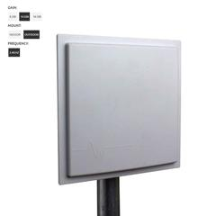

Panel Antenna

The 14 dBi panel antennas selected for this design have a 35 degree beam width can achieve ranges between 1 to 4 miles depending on the presence of a line of sight. The antenna will be mounted in a array with 4 panel antennas mount 90 degree to each to receive signal from 4 different directions. Each panel antenna can be adjusted independently in order to adjust their orientation to achieve the best reception.

The WiFi signal from the node modules can be split using a 1 to 4 splitter similar to what is shown below. The signal is distributed among the 4 antenna. Note that the effective range of each antenna is reduced as the power of the signal is divided equally among the 4 antenna. There is an additional 1 dB lost of power due to the splitter. As the effective range is reduce to approximate less than ¼ of the power the range is also reduced. As a result the spacing between nodes is less and greater density per square mile is required. This may or may not be an issues depending on the architecture of the network deployment.

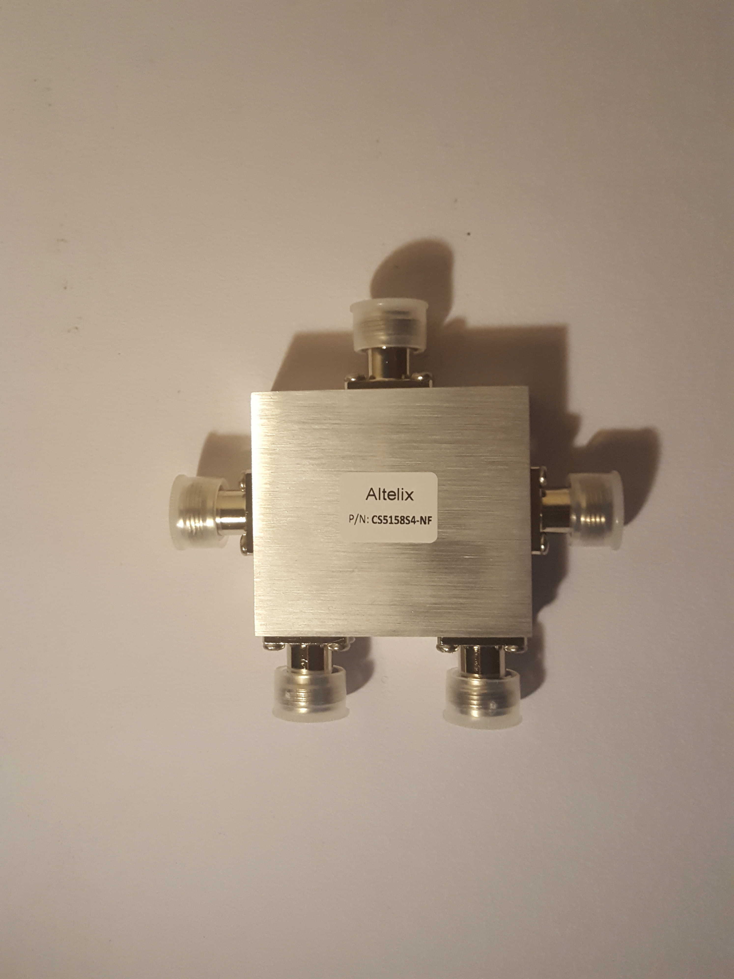
1 to 4 Signal Splitter

If the nodes of the mesh network are laid out in a grid then each node in the mesh network is setup to split the signal of their WiFi transceiver between 4 antenna so that the can connect to the nodes around them. A four way splitter is used to distribute the signal to the four antenna.

Four way splitters typical have an insertion loss of 6 dB and the signal is then subsequently divided among 4 antennae essentially dividing the power of the transmitter by 4. There will also be a loss where the cable from the splitter connects to the antenna.

Low cost 4 way splitter can be source from Asian suppliers in small quantities:

http://www.alibaba.com/product-detail/4-way-splitter-800-2500mhz_60308104723.html?spm=a2700.7724838.2017115.108.3c93b095OlHUfH

Most common 2 way splitters can be used and connected in series but each stage introduces and additional insertion loss of power.

Each node in the mesh network has 2 WiFi transceivers. One transceiver is setup to route traffic between nodes in the mesh network. The other transceiver is setup to provide an access point to people in the vicinity of the node in the mesh. The access point will typical use an omni-directional antenna. Depending on the power of the transmitter in the access point mobile devices within 10 meters to 30 meters can receive the signal. Depending on the class of the transceiver in the mobile device handset users can expect similar ranges.

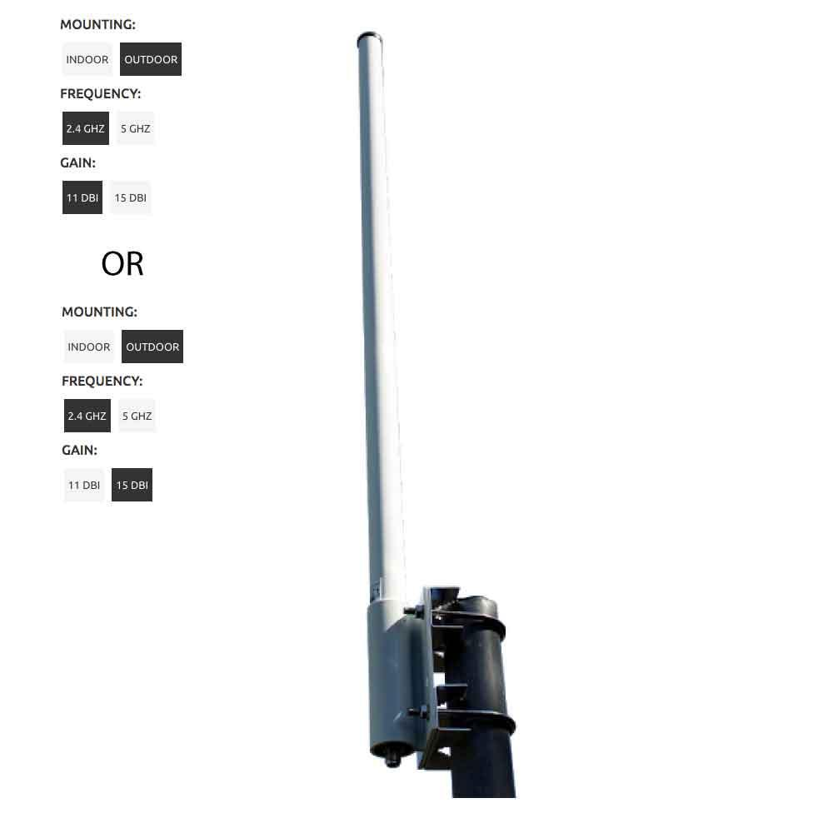
15 dBi Omni-direction antenna

Given the cost of each node which will be discussed below it will be expensive to deploy nodes every 30 meter. It is more practical to setup node with more distance between them and have people travel to the access point.. As a result the mesh node might be setup more like the phone booth at the general store where users need to travel a ways to get to the nearest node to get service. Node can therefore be spaced miles apart if necessary.

There is not one specific design that will meet the need of every community. The current design is flexible enough that if can be configured to the needs of the community. As main of the components are off the set and no custom boards or advance fabrication techniques are required. The system can be scaled and modified comparative easily.

Note that for WiFi implementations the output of each antenna can not exceed 36 dBm in effective isotropic radiate power (EISP).

“Effective isotropic radiated power both measure the amount of power a radio transmitter and antenna (or other source of electromagnetic waves) radiates in a specific direction: in the direction of maximum signal strength (the "main lobe") of its radiation pattern. The maximum radiated power is dependent on two factors: the total power output and the radiation pattern of the antenna – how much of that power is radiated in the desired direction. The latter factor is quantified by the antenna gain, which is the ratio of the signal strength radiated by an antenna to that radiated by a standard antenna. For example, a 1,000-watt transmitter feeding an antenna with a gain of 4 (6 dBi) will have the same signal strength in the direction of its main lobe, and thus the same ERP and EIRP, as a 4,000-watt transmitter feeding an antenna with a gain of 1 (0 dBi). So EIRP is a measure of radiated power that can compare transmitters with different antennas on an equal basis. “

There are exceptions to the above rule for point to point link which apply to the nodes in the mesh network.

“Maximum transmitter output power, fed into the antenna, is 30 dBm (1 watt).

Maximum Effective Isotropic Radiated Power (EIRP) is 36 dBm (4 watt).
You can obtain the EIRP by simply adding the transmit output power, in dBm, to the antenna gain in dBi (if there is loss in the cable feeding the antenna you may subtract that loss).

If your equipment is used in a fixed point-to-point link, there are two exceptions to the maximum EIRP rule above:

In the 5.8 GHz band the rule is less restrictive. The maximum EIRP allowed is 53 dBm (30 dBm plus 23 dBi of antenna gain).
In the 2.4 GHz band you can increase the antenna gain to get an EIRP above 36 dBm but for every 3dBi increase of antenna gain you must reduce the transmit power by 1 dBm. The table below shows the combinations of allowed transmit power / antenna gain and the resulting EIRP.

Transmit Power  (dBm) | Antenna Gain  (dBi) | EIRP  (dBm)
30 | 6 | 36
29 | 9 | 38
28 | 12 | 40
27 | 15 | 43
26 | 18 | 44
25 | 21 | 46
24 | 24 | 48
23 | 27 | 50
22 | 30 | 52

”

In the case of the design of the CEMN system we are using 15 dBi panel antenna and the power of the transmitter is also being reduce by the 4 way splitter so depending on the power of the transmitter it is possible to get more effective EIRP than 36 dBM and therefore get more range.

Power System for the Nodes

Each node is designed to be powered by 5 volts and nominal with 2 or less amps of current for the access point nodes and 12.5 amps for the server nodes. Maximum power draw also depends on the amount of system traffic as the transceivers draw more power with they are actively transmitting. The actual power budget for each node is specified below.

Solar Charging Circuit

The power system needs to provide power to power the electronics when the node is active during the day and in the evening or on cloudy days when the battery must provide the power. In addition to providing direct power to the system, the solar power system must product sufficient power to also charge the battery. An off the shelf solar panel and solar charge controller system was selected to drive the system. The solar charge controller stops the solar panels from drawing power from the batteries at night and prevents the batteries from being overcharged which would impair the long term effectiveness of the batteries.

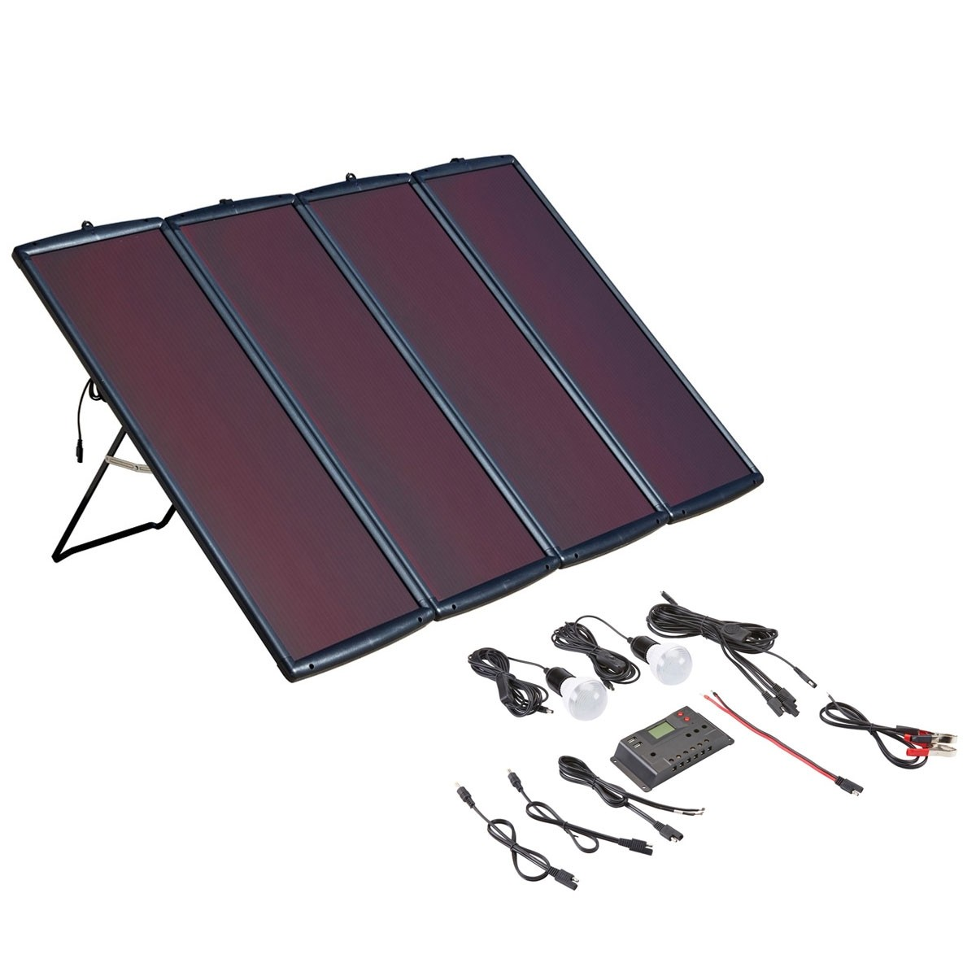

This design can use 6 volt batteries as the electronic for the system require 5 volts. But 12 volt batteries could also have been used and the voltage regulated down to 5 volts.

Batteries Capacity Calculation

“Telecom backup powering has shifted from ‘graceful shutdown’ of 15-30 minutes backup power to ‘operational’ backup of 4-8 hours or more. Whether supporting customer premises equipment, channel banks, switches and RTU’s for wired applications, or microwave backhaul, base stations, distributed antenna systems (DAS), or POP sites in a tower for wireless applications, battery backup power is needed for longer periods to ensure continuity of operation. SEI’s DC UPS provides a convenient, scalable platform to meet these critical power and battery backup requirements.”

In regions where it rarely rains the battery capacity of the system only needs to accommodate for running of the system at night when there is no sun to directly power the electronics in each individual nodes. There are essentially two configurations that need to be accommodated:

- the nodes that acts as just an access points and individual node in the mesh network
- the nodes that act as access points, as node in the mesh network and as either a registration server or message server.

The power draw of the components for an access node are shown in the below tables:

Component Name | Unit cost | Power usage per unit
Raspberry pi 3 ( AP and mesh network node ) | $35 | 3.7W (%100)
LimeSDR( AP) | $99 | 3 W ( USB 2)
LimeSDR(mesh network) | $99 | 3 W ( USB 2)
14 dBi Panel Antenna | 4 x $64 = $256
Omni-directional antenna | $79
Solar Panel Kit | 2 x $145 = $290 | 9.7 watts (1.94 amps)
Batteries | 4 x $300 = $1200
Inflatable Tower | $2500 to $10,000
Total | $5,163 to $12,663

The second style of nodes are the server nodes. The server nodes contain the schedulers, load balancer, registration servers and message servers.
Component Name | Unit cost | Power Requirement
fitlet2 (Scheduler server ) | $200 | 10 to 15 watts
fitlet2 (Load balancer server ) | $200 | 10 to 15 watts
fitlet2 (XMPP messaging server ) | $200 | 10 to 15 watts
fitlet2 (Registration server ) | $200 | 10 to 15 watts
LimeSDR(mesh network) | 2 x $99 = $198 | 3 watts
14 dBi Panel Antenna | 4 x $64 = $256
Omin-directional antenna | $79
Solar panel | 7 x $145 = $1.015 | 63 watts (12.6 amps)
Battery | 27 x $300 = $8,100
Tower | $2500 to $10,000
Total | $12,948 to $20,448

In general lead acid batteries can not be completely drained, once the voltage drops below the equipment’s requirements it will no longer be able to power the system. Lead acid batteries will give you around 50% of their rated power. (i.e. a 10Ah battery has 5Ah of usable power).” Deep cycle batteries need to be selected as they are designed to be discharged slow and re-charged quickly. Car batteries on the other hand are design to provide a lot of power quickly but it’s not able to cope with a low internal charge and recover fully.

To calculate the amount of battery capacity required and the size of the solar panel the following assumptions are being made:

the electronics of node access point nodes draw 1.94 Amp
the electronics of nodes with servers incorporate draw 12.6Amps
corresponding power requirement per day is therefore (assuming 12 volt nominal voltage for simplicity):
Power = Voltage x current x number of hours of use
= 12 volts x 1.94 Amps x 24 hours = 280 watt-hours
= 6 volts x 12.6 Amps x 24 hours = 1815 watt-hours
The system must be able to run for 2 days without sun in order to provide extra capacity in the case of cloudy or rainy day where the charge being generated by the solar panel will be non-existent
4.2 hours of sunlight is available each day for charging the system (based on the amount of sun in Los Angeles California, the number of hours of sunlight will be longer in tropical regions)
The follow calculator produces the following battery capacity and solar panel requirements:

https://www.altestore.com/store/calculators/off_grid_calculator/

For the access point nodes without server components:

1417 Amp-Hours of capacity are required
Solar panels of at least 107 watts

For the nodes with servers components as part of the electronics:

9814 Amp-Hours of capacity are required
Solar panels of at least 694 watts

Note that the calculation assume only a 50% discharge to your batteries to optimize battery life.

Potential choice for the batteries are the Deka Solar Flooded Wet Cell Battery 6V 370 AH, LTP Terminal 8L16LTP deep cycle lead acid batteries. As with any high capacity battery the weight is an issue coming in at 113 pounds. Comparable Lithium ion batteries are only slight lighter (93 pounds) , cost 10 times as much and require more complex charging circuitry.

Usage patterns will ultimately determine how much battery capacity is actually required.

Solar Panel Selection for the System

As shown in the calculations above solar panels with at least 107 watts of capacity are required for the basic node access point and at least 694 watts is required for nodes with the servers installed. As with all the pricing in this project we have sourced from American suppliers know that it is possible to achieve lower pricing from Asian suppliers. The exact pricing typical depends on the volume of each part ordered. Not knowing the specific quantity required for a specific application we are making the assumption that the lowest American prices will be the high end of the range when the equivalent part is source from an Asian supplier. We do know that shipping from America suppliers can be expensive relative to the cost of the parts in some cases. In an actual implementation the final price will depend on the price achieved from Asian suppliers. There are some historical international treaties that provide low price shipping to specific regions of the world.

A typical low cost unit is this 100 watt solar kit for $145.

https://www.harborfreight.com/100-watt-solar-panel-kit-63585.html

Lower pricing can be achieve when ordering from Asia suppliers:

https://www.alibaba.com/product-detail/2015-hot-sale-in-Africa-most_60243891407.html?spm=a2700.7724838.2017115.73.6152e033oFBCbq

Lightning Strike Protection

In some parts of the world lightning strikes are a real hazard. To protect the equipment it is recommended that lightning arrestors be installed. The lightning arrestor are install in line with the antenna cable. When the voltage exceeds the discharge voltage, the surge suppressor instantly dumps the voltage safely to ground. They can withstand multiple lightning strikes.
For simplicity, inline lightning arrestor are recommended in this design.

A typical lighting arrestor is available from a supplier like RadioLabs:

N-Male x N-Female Inline Mount

The arrestor can introduce a 0.4db Max Insertion Loss and has a breakdown voltage of 350V or 90V. Typical single unit pricing is $29.

Packaging of Each Node in the Mesh Network

The packaging of the electronics for the nodes will be initially in 3D printed enclosures. That can be converted to injection moulded enclosure if the system goes into production. The key components of the enclosure are weather sealed, rugged and environment durable. At the time of this proposal the enclosure have not been designed. The designer have experience with 3D modelling and 3D printing.

Architecture for the Network Layout

When we think of the coverage of networks in dense urban setting in developed countries we think of ubiquitous, 24 hour a day, seven day a week access to the network. We forget there was a time when people went to the corner drug store to make a phone call because they could not afford to have a telephone in their house. In the same way the Community Engagement Mesh Network can be set up to be a dense network where everyone gets coverage 24 hours a day and seven days a week or the network can be set up to be a series of regional access points where you need to travel to the local hotspot in order to use the network.

Most mobile phones have a WiFi transceivers in them that typical have a range of 10 to 30 meters (class 1 transceivers). As a result to have always on ubiquitous access to the system the nodes in the mesh network can be placed at the most 20 to 60 meters apart. Nominally the placement will be closer together in order to prevent “dead zones”, spots where there is no or weak coverage. The WiFi Access Transceiver of a mesh node is designed to have an omni-directional antenna. An omni-directional antennae has a spherical range of coverage. The spherical regions need to overlap to reduce the size of any potential dead zone where the signal is weak or not sufficient to be usable.

Increased density requires increases cost as more nodes need to be deployed. A compromise is the have a denser network near the densely populated parts of a community such as the city center and local access points where people have to travel to use the service in the further outlying parts of the community. Single panel antenna configurations of the design in this system have a tested ranges of up to ¾ mile without go line of sight between antenna, properly align parabolic antenna have even longer ranges of many miles provided there is a clear line of sight between antenna. It is important to know how the WiFi protocol acknowledges each received frame. If the acknowledgement is not received, the frame is re-transmitted. By default, the maximum distance between transmitter and receiver is 1.6 km (1 mi). On longer distances the delay will force retransmissions if they use the order 802.11 WiFi protocols. Using the newer 802.11 n or 802.11 ac longer range transmissions are support as the re-transmission time has been extended.

The layout of the nodes also affect the design of the antenna array attached to each node in the mesh network. A grid layout of the network means the each antenna array can have 4 directional antennas configured perpendicular to each other so that each node have access to the 4 adjacent nodes to it in the grid pattern, if it is laid of that way. Different network layout require different antenna array designs. As mention above if the signal is split then the effective range is reduced as the power of the signal is evenly distribute to each antenna. While power amplifiers are available to amplify the signal they also need to be powered by the system and they can cost as much as all the other components and modules in an mesh node access point.

The overall network layout for a community needs to be customized to the needs of the particular community. The available budget, the density of the neighbourhoods in the community and the topology of the local terrain all have an effect on how the network architecture needs to be designed.

Connecting the Mesh Network to the Outside World

Though this system was designed to run as an isolated, independent network it is possible to connect it to the world outside the disaster area. Satellite communications systems exist to provide high speed internet access that can facilitate voice and data. Systems like the Hughes 9202 BGAN Terminal are available but pay-as-you-go plans have high voice and data minute costs ($6.99 per megabit of data, $0.99 per minute voice, $0.60 per text message sent, free received text message with a $69 per month recurring fee on a 12 month contract). Restricted unlimited plans cost $4555 per month regardless of whether the system is being used or not. The plan provides for 30 Gigabits of data at 464 kilobits per second and then data rates convert to 128 kilobits per second. Voice call are at $0.99 per minute with free incoming call and text messages at $0.50 outgoing and free incoming. So while that cost of the hardware is affordable on a relative basis the recurring costs can be expensive. As a result the architecture for the CEMN system is designed to contains a limited number of satellite equipped access nodes to be used for first responders, emergency service and government officials to use to coordinate outside relief efforts. It is noted that the majors of relief and rescue efforts is going to have to come from local resources just because of the logistics of moving a large number of people and equipment from outside what could be a large geographic disaster area. Satellite communication has the advantage of not relying on an establish network of land based nodes to achieve a large coverage area.

It should be noted that the FaradayRF open source initiative that uses the 33 cm HAM radio band has comparable data rates (500 kilobits per second) without the associated costs. A network of transceivers need to be setup ahead of time though to make sure a geographically diverse network is in place before hand. With the proper line of sight alignment distance of 40 miles have been claimed by the designers. HAM radio operator have historically provided communications in times of disasters and the FaradayRF initiative provides the ability to enhance those capabilities by adding data transfer abilities. By internet standards the 500 kilobits per second data rate is slow and will not handle the requirements of the message traffic for the CEMN system, but as stated previously above the 2 FSK (frequency shift keying) modulation data transfer can be used to connect isolated parts of the mesh network that implement the faster WiFi connectivity. The FaradayRF based approach can in some situation allow the CEMN network architecture to overcome specific geographic or man made obstacles that would either restrict the reach of the network or require a series of high density deployment to go around the obstacles. The lower carrier frequency gives the radios longer range and a greater ability to reflect around obstacles. Similar the higher power of the radios can give the node more range.

Towers

In order to maintain portability the system will use inflatable towers. These tower are manufactured by LTA Projects coming in different size and load bearing capacity. Height range from 12 feet to 60 feet and load bearing capacities of 9 pounds to 28 pounds. These typically have a 45 inch diameter and can weight between 65 and 105 pounds.



The best compromise of height versus load bearing capacity is the Comet 37. It has a height of 37 feet and can hold a payload of 28 pounds. The diameter of the system found is 45 inches and the weight is 110 pounds. It takes 40 minutes to inflate using an air pump attached to the power system of a car through an inverter.

The system is designed to transported in a car trunk or on the bed of a truck.

Cost Comparison

There were 2 type of nodes in the CEMN architecture. The first is the basic access point (AP) node used to allow people to connect to the services of the network.

Component Name | Unit cost | Power usage per unit
Raspberry pi 3 ( AP and mesh network node ) | $35 | 3.7W (%100)
LimeSDR( AP) | $99 | 3 W ( USB 2)
LimeSDR(mesh network) | $99 | 3 W ( USB 2)
14 dBi Panel Antenna | 4 x $64 = $256
Omni-directional antenna | $79
Solar Panel Kit | 2 x $145 = $290 | 9.7 watts (1.94 amps)
Batteries | 4 x $300 = $1200
Inflatable Tower | $2500 to $10,000
Total | $5,163 to $12,663

The second style of nodes are the server nodes. The server nodes contain the schedulers, load balancer, registration servers and message servers. schedulers, load balancer, registration servers and message servers.
Component Name | Unit cost | Power Requirement
fitlet2 (Scheduler server ) | $200 | 10 to 15 watts
fitlet2 (Load balancer server ) | $200 | 10 to 15 watts
fitlet2 (XMPP messaging server ) | $200 | 10 to 15 watts
fitlet2 (Registration server ) | $200 | 10 to 15 watts
LimeSDR(mesh network) | 2 x $99 = $198 | 3 watts
14 dBi Panel Antenna | 4 x $64 = $256
Omin-directional antenna | $79
Solar panel | 7 x $145 = $1.015 | 63 watts (12.6 amps)
Battery | 27 x $300 = $8,100
Tower | $2500 to $10,000
Total | $12,948 to $20,448

Note that the majority of the cost is in the power system (solar panels and batteries) and the towers for each node with most of the cost being the tower. The cost of the tower varies with the height. 12 foot towers cost about $2500 and 61 foot tower cost about $10,000. Payload for each tower design also varies from 8 pound to 28 pounds. A good all around compromise is the Comet 37 Tower which has a height of 37 feet and a maximum payload of 28 pound.

Portability

The final design with enclosures have not been completed at the date of this proposal. The majority of the weigh is in the towers, solar panels and batteries. The actual electronics of the nodes weigh only a few pounds (estimated 3 pound for access point node and 7 pounds for the server node). The weigh of the Comet 37 Tower is about 110 pounds and 45 inches in diameter with the tower collapsed and the weight of the Air 60 Antenna tower is 105 pounds with a 45 inch diameter when collapsed.
The batteries are approximately 72 pounds each and the dimension at 10.3” L X 7.11” W X 11.90” high. The solar panels with charging units weight about 33 pound and have 39” L X 14” W x 1” H. The panel antenna are approximately 12” x 12” in dimension The weigh and size means a complete unit needs to be transported in the trunk of a car or a truck. It can be set up by two people easily and one person if necessary.

The electronics of the nodes with a small battery and the panel antennas can be used to setup more portable short term nodes using light weight tripods for quicker deployment. The compromise will be the range between nodes in the mesh network as line of sight over long distances close to the ground might be more difficult to achieve. Depending on whether it is a access point node or a server node a light weight battery may only have the capacity to power the node for a few hours. Depending on the situation that might be sufficient for some applications.

Feasibility of the Design

This is a mesh network telecommunications system designed to be deployed in the immediate after math of a disaster. It is based on a telecommunication system designed to be deployed in un-served communities in developing countries (CEMN - https://hackaday.io/project/21641-cemn-community-engagement-mesh-network). The original system focused on minimizing cost, being able to be manufactured locally and being able to be assembled and maintained with people without advanced technical skills. The focus of this system is ease of deployment, large geographic coverage area, robustness of design, high user capacity, being able to be powered in a region with unreliable power and scalability. The project draws heavily from open source initiatives in order to ensure the design can be easily build and easily improved upon. Core elements like the message service, registration server, access points and bridges in the nodes of the mesh have been test in the original CEMN design.

The new elements of the design such as the scheduler, load balancer and servers were implemented to handle the higher demand and load on the system anticipated in an intermediate to large urban environment. They are all drawn from existing open source designs. The source code for the scheduler needs to be modify to implement priorities of service. First responders and emergency service organizations will have access to a limited number of voice channels (128 kilobits per channel). They will also have priority access to the messaging service that forms the core of the communication system in this network. After these services text messages to the 911 user id will have the next highest priority. Other text message will have the next level of priority. Access to first aid and survive instructions will be dealt with an best efforts basis and as the bandwidth in each of the nodes allows. The load balancer software is a tested design and is already active in other implementations.

The Software Defined Radios that make this design unique in terms of the configurability of the system to improve geographic coverage and system throughput are also based on a proven open source hardware design. The different protocol stacks necessary to implement the specific wireless protocols have not yet be implemented as open source designs yet but the open source hardware was specifically build with these protocols in mind. The LimeSDR software defined radios were designed to create an open source reference design in order to make specific wireless network protocol stacks become “software as a service” and the designer will be contributing to that code based during this project. GNU radio, an open source visual programming suite for software defined radio, is compatible with the LimeSDR radio. The way to install the LimeSDR compatible GNU radio is covered in Appendix C . An LTE implementation based on the LimeSDR hardware has already been implemented by Amarisoft and Quortus. The OpenAirInterface initiative created a test base station with the LimeSDR to implement a LTE cell that enabled a 20 Mbps transfer rate for both down and uplink. EURECOM has created the OpenAirInterface (OAI) Software Alliance (OSA), a separate legal entity from EURECOM, which aims to provide an open-source ecosystem for the core (EPC) and access-network (EUTRAN) protocols of 3GPP cellular systems with the possibility of interoperating with closed-source equipment in either portion of the network. The tools are there to create other stacks to implement protocols like 802.11 ac and 802.11 n and a implementation of the FaradayRF data transfer protocol. Sufficiently time to implement the stacks will be the major challenge during the course of this project.
The designers hope to use the HackADay community to get other designers to join the initiative.

The ability to prioritize communications in the system can be achieved through service already available in the message server (XMPP). Only an appropriate front end needs to implemented via the scheduler. The mesh architecture that connects the node together is based on the open source BATMAN (Better Approach to Mobile Adhoc Networking) initiative. This design is intended to minimize the technical risk by drawing on many open source initiative. There are still technical risk in the integration process and in some case the component pieces still need to be customized in order to them to work together with the other pieces and deliver the performance set out in the technical specification. The performance of some of the hardware components like the inflatable antenna towers have not been tested in extreme conditions by the designer. They are relying on the technical specification provided by the manufacturers. Like all new designs it is difficult to know the performance of the design without an actual deployment and the conditions under which this design must work are at the extremes. The designers have tried to minimize the risk by choosing components that have been deployed in similar applications.

The core messaging elements of the App to access the services of the network have been completed as part of the original CEMN implementation for under developed countries. The ability to access the user’s contact list to reference users by their phone number as part of the registration server process has not been implemented as that is unique to CEMN – disaster zone design. This feature was created to facilitate end user contacting each other. During a disaster there is no time or mechanism to exchange new UserNames for users not already registered with system. Most people have access to phone number in their contact list. The App will use the contact name to display end users in the App but the Registration Server will use phone numbers as the UserNames in its database. The scheduler process also needs to be implemented. To ease the load on the network the App receives a time slot to send or receive messages. In the current design the App will keep trying till it gets a connection. In the original CEMN design bandwidth was not at a premium so it was not necessary to schedule time slots.

The webpage to access the message system as a web service also needs to be created. The original CEMN design used an App in order to maintain the highest degree of privacy. Without access to the physical handset of a user it was difficult to determine the actual person using the service. In a disaster situation giving up a degree of privacy for timely access to services and information is an acceptable compromise. Webpages also have to be created to provide access to the mapping app and first aid and survival information. The designers have created similar web pages before so the risk is low.

Summary

What started as a conversation by two friends about providing a low cost, easy to manufacture local communication system for remote, underserved communities in developing countries has evolved into the current design for a communication system for disaster areas in any region of the world. Many of the design requirement for the original Community Engagement Mesh Network apply to this current design: able to be setup with people with limited technical skills, able to be powered in area where no power or unreliable power exists, able to tolerate failure of some of the nodes of the network and still provide adequate performance and able to run with no to little maintenance for an extended period of time. New hardware and software features have been added to handle a large volume of request in a short period of time ( 500,000), new prioritized service in the form of voice and message service to augment or take the place of the communication needs for first responders and emergency service organizations, the ability to broadcast alerts to subscribers, ability to provide access to critical applications and information and portable so it can be deployed quickly in areas that need it .

The design of the application that people use to engage with the system and the other services provided draw heavily from work done by FEMA and the FCC on how to communication in a disaster situation. People have to register to use the system. The application uses the contact list of the user on their phone so that it is easier for the users to find the people that want to contact. Recipients are registered using their phone number on the system as it is a unique identifier. The user still see the information in their contact list when selecting a recipient by name.

Like all systems capacity is an issue in emergency situations are there is a huge surge in requests from people requiring emergency service and people trying to contact loved ones to see if they are alright. The system provide prioritized services to first responders and emergency service organizations for text messaging and limited voice capabilities. Voice takes up large amount of bandwidth (128 kilobits per second) so it is reserved for more pressing needs.

In the potential absence of landmarks after a disaster the system provides access to an App that provides longitude and latitude information along with a compass. The App draws on the GPS features of the phone so that no internet access is necessary. The traditional maps that users are familiar with potential could have not meaning as an earthquake may have destroyed street signs and building landmarks. Similar flood may obscure all familiar landmarks. Bulletin that refer to rallying points for emergency aid and relief supplies are more likely to refer to longitude and latitude coordinates or large geographic features such as rivers or mountain in the aftermath of a disaster.

Access to instructions on first aid and survival instructions are important in the aftermath of a disaster. First responders and emergency service organizations are typically overwhelm so many people with have to band together to help themselves to help can arrive. Information on how to deals with common situation is necessary in the absence to actual trained medical and emergency workers.

A single cellular tower cost approximately $200,000 to $300,000 in install. The CEMN system cost is approximately $12,000 for each node with most of the cost associated with the solar power panel, the batteries and the tower assembly. Depending on the configuration the CEMN system does not have the same coverage as a cellular tower due to the potentially reduced power of the radios and the lack of access to the high cellular tower sites. It is assumed that buildings will be dangerous to enter in some disaster situation so access the same locations as existing cellular tower may not be possible. The inflatable antenna towers chosen for this design are a compromise between portability and height.

The differentiating aspect of this design is the use of software defined radios (SDR).SDR allow the organization or community deploying the system to use the protocols most appropriate to their situation. If deployed by an existing wireless service provider the nodes can use the existing LTE spectrum licensed to them. In the case where some of the infrastructure remains intact the CEMN node can act as replacements for the impaired or damage LTE tower, The advantage of this approach is that user can use their existing phone and applications with restrictions. Voice calls would still be restricted to preserve bandwidth. In the case where the deploying agency does not want deals with licenses WiFi protocols allow them to deploy a system without worrying about interference with other licenses bands. WiFi has the disadvantage of having limited range despite the new variants that are designed to facilitate long range connections. The limited Effective Isotropic radiate power of 20 dBi limits the range. In ideal situations with good line of sight WiFi can have a range of many miles but in urban setting good line of sight is not the normal. WiFi has the advantage of provide has high bandwidth for data transfer. Transfer of data on HAM Radio bands are a potential compromise as HAM radio operators can use transmitter more powerful that WiFi radios and the use lower frequency carriers that have better propagation properties. Data transfer schemes such as the open source FaradayRF project provide longer range transmission and reception but have lower data rates of 500 kilobits per second. All these protocols can be facilitated through a single software defined radio design. Systems that mix the technologies to deal with geographic and man made obstacles that block or impair transmission of one particular technology is also possible.

The majority of the design for the CEMN system focuses on localized communication as it is recognized that help may be many hours, days or weeks away depending on how much of the physical infrastructure has been destroyed. Facilities to connect to the outside world are provided in the form of access to satellite phone and data links. Satellite data links are typically available in the 400 kilobits per second data rate so high bandwidth. High throughput is not a practical reality with these systems. Combined with high cost ($4,555 per month) for restricted unlimited data it is not practical to deploy large number of satellite phones.

The CEMN system strikes a compromise between the need to deploy quickly, relative affordable cost and performance. It uses a combination of tested technology that has not been integrated before in one system. The system is design to be feasible with low technical risk as the component parts have proven to work in other systems.

Appendix A: Setup Instructions

Download and install the necessary packages
Install the necessary packages ( All nodes )
sudo apt-get update
sudo apt-get install git
sudo apt-get install iw
sudo apt install libnl-3-dev libnl-genl-3-dev
sudo apt-get install -y bridge-utils hostapd dnsmasq batctl

Download the source code from github
git clone https://github.com/Arznix/CEMN-Chat-Mesh-Network.git

Download and install the Registration server node (Registration node)

Install Mongodb
Install mongodb
sudo apt-get install mongodb-server

Start it as a service when the raspberry pi starts
sudo service mongodb start

Install nodejs and npm

Download nodejs
wget https://nodejs.org/dist/latest-v6.x/node-v6.11.4-linux-armv7l.tar.gz
tar -xvzf node-v6.11.4-linux-armv7l.tar.gz
sudo mv node-v6.11.4-linux-armv7l /opt/node
sudo mkdir /opt/bin
sudo ln -s /opt/node/bin/* /opt/bin/

Add the binaries in the PATH
sudo nano /etc/profile
PATH="/usr/local/sbin:/usr/local/bin:/usr/sbin:/usr/bin:/sbin:/bin:/opt/bin"
Check that everything is okay by taping these commands:
npm --version
node -v

Setup Registration server and add it as a service

Install Registration server packages
cd ~/CEMN-Chat-Mesh-Network/Registration-Server
npm install
Test Registration server

node server.js

Add cemn_registration.sh startup scripts to init.d as a service
sudo cp /home/pi/CEMN-Chat-Mesh-Network/Registration-Server/cemn_registration.sh /etc/init.d/cemn_registration

Next, we’ll need to make the cemn_registration executable.
sudo chmod 755 /etc/init.d/cemn_registration

Add cemn_registration service to startup services.
sudo update-rc.d cemn_registration defaults

Check if service is running
sudo service --status-all

Install and configure XMPP if it's XMPP server node ( XMPP node )
sudo apt-get install ejabberd
sudo dpkg-reconfigure ejabberd
Note: Select localhost as default service name

Setup batman-adv mesh network ( All nodes )
Make sure both USB Wifi cards are running using iw dev command. We use wlan2 to setup batman-adv mesh network and wlan0 to setup Wi-Fi access point since we are using an external USB Wi-fi card to setup mesh network and the Raspberry pi 3 internal
Wifi chip to setup access point.
iw dev

Update the wlan number in cemn_mesh.sh located in Mesh-Network directory. It will be the wlan you selected in previous step to setup batman-adv mesh.
cd ~/CEMN-Chat-Mesh-Network/Mesh-Network
sudo nano cemn_mesh.sh

Content of cemn_mesh.sh:
#!/bin/bash

### BEGIN INIT INFO
# Provides: cemn_mesh
# Required-Start: dbus
# Required-Stop: dbus
# Should-Start: $syslog
# Should-Stop: $syslog
# Default-Start: 2 3 4 5
# Default-Stop: 0 1 6
# Short-Description: CEMN mesh server
# Description: CEMN Mesh server
### END INIT INFO

# Activate batman-adv
sudo modprobe batman-adv
# Disable and configure wlan2
sudo ip link set wlan2 down
sudo ifconfig wlan2 mtu 1532
sudo iwconfig wlan2 mode ad-hoc
sudo iwconfig wlan2 essid cemn-mesh-network
sudo iwconfig wlan2 ap 02:12:34:56:78:90
sudo iwconfig wlan2 channel 3
sleep 1s
sudo ip link set wlan2 up
sleep 1s
sudo batctl if add wlan2
sleep 1s
sudo batctl ap_isolation 1
sleep 1s
sudo brctl addif br0 bat0
sleep 1s
sudo ifconfig wlan2 up
sudo ifconfig bat0 up
sleep 5s
# Use different IPv4 addresses for each device
#sudo ifconfig bat0 172.27.0.xxx/16

Add cemn_mesh.sh startup scripts to init.d as a service
sudo cp /home/pi/CEMN-Chat-Mesh-Network/Mesh-Network/cemn_mesh.sh /etc/init.d/cemn_mesh
Next, we’ll need to make the cemn_mesh executable.
sudo chmod 755 /etc/init.d/cemn_mesh
Add cemn_mesh service to startup services.
sudo update-rc.d cemn_mesh defaults
Comment out the unused script in /etc/rc.local
Remove psk and ssid from wpa_supplicant.conf
sudo nano /etc/wpa_supplicant/wpa_supplicant.conf
Setup Access point and bridge ( All nodes )
Edit line #20 in /lib/udev/rules.d/75-persistent-net-generator.rule file and add "wlan*|"
sudo nano /lib/udev/rules.d/75-persistent-net-generator.rule
Note: This will generate /etc/udev/rules.d/70-persistent-net.rules file
Reboot the node
sudo reboot
Check the wifi chips have correct wlan interface
sudo nano /etc/udev/rules.d/70-persistent-net.rules

Note: We are using another USB Wifi card to setup Wi-Fi access point in Raspberry pi 3. so, We will be using wlan0.

Configure a static IP for wlan0 by opening up the interface configuration file with following command:
sudo nano /etc/network/interfaces

allow-hotplug wlan0
iface wlan2 inet static
address 10.0.0.xxx
netmask 255.255.255.0

auto br0
iface br0 inet static
address 192.168.4.xxx
netmask 255.255.255.0
bridge_ports bat0 wlan0
bridge_stp off

iface default inet dhcp

For example: The address for first node will be 10.0.0.1

Restart dhcpcd
sudo service dhcpcd restart
Reload the configuration for wlan0 with following command
sudo ifdown wlan0; sudo ifup wlan0
Create a new configuration file and add Access point configuration settings to it
sudo nano /etc/hostapd/hostapd.conf

Content of /etc/hostapd/hostapd.conf:

# This is the name of the WiFi interface we configured above
interface=wlan0
# This is the name of the bridge interface which is used if you are bridging mesh network and access point
bridge=br0
# Use the nl80211 driver with the brcmfmac driver
driver=nl80211
# This is the control interface
ctrl_interface=/var/run/hostapd
ctrl_interface_group=0
# This is the name of the AP and should be different for each node
ssid=CEMN-AP1
# Use the 2.4GHz band
hw_mode=g
# Use channel 6
channel=6
# Enable 802.11n
ieee80211n=1
# Enable WMM
wmm_enabled=1
# Enable isolation mode
ap_isolate=1
# Accept all MAC addresses
macaddr_acl=0
# Use WPA authentication
auth_algs=1
# Require clients to know the network name
ignore_broadcast_ssid=0
# Use WPA2
wpa=2
# Use a pre-shared key
wpa_key_mgmt=WPA-PSK
# The network passphrase
wpa_passphrase=cemnberry
# Use AES, instead of TKIP
rsn_pairwise=CCMP
beacon_int=100
ieee80211n=1

Check if it's working at this stage by running following command:
sudo /usr/sbin/hostapd /etc/hostapd/hostapd.conf

You should get something similar to following message:

"Configuration file: /etc/hostapd/hostapd.conf
Failed to create interface mon.wlan2: -95 (Operation not supported)
wlan2: Could not connect to kernel driver
Using interface wlan0 with hwaddr b8:27:eb:69:f2:10 and ssid "CEMN-AP1"
random: Only 18/20 bytes of strong random data available from /dev/random
random: Not enough entropy pool available for secure operations
WPA: Not enough entropy in random pool for secure operations - update keys later when the first station connects
wlan0: interface state UNINITIALIZED->ENABLED
wlan0: AP-ENABLED"

Hit CTRL+C to brake operation
Set Host Access Point Daemon to start his job at system startup:
sudo sed -i "s/^.*DAEMON_CONF=.*$/DAEMON_CONF=\"\/etc\/hostapd\/hostapd.conf\"/" /etc/default/hostapd
Install DHCP and DNS server configuration:
cat > /etc/dnsmasq.conf <<EOF
interface=br0
address=/#/192.168.4.1
address=/google.com/0.0.0.0
dhcp-range=192.168.4.101,192.168.4.254,255.255.255.0,1h
EOF
Enable IPv4 packet forwarding instantly:
sudo sh -c "echo 1 > /proc/sys/net/ipv4/ip_forward"
Enable IPv4 packet forwarding at system startup:
sudo sed -i "s/^.*net\.ipv4\.ip_forward=.*$/net\.ipv4\.ip_forward=1/" /etc/sysctl.conf
Restart wireless network interface, Host Access Point Daemon, DHCP and DNS server:
sudo ifdown wlan0;sudo ifup wlan0
sudo service hostapd restart
sudo service dnsmasq restart
Reboot the node
sudo reboot

Testing
Testing mesh network and access point
iw dev
sudo ifconfig
sudo batctl o
Test XMPP server
Connect to AP and login using following link:
http://172.24.1.1:5280/admin/
Change the Symmetric key and IP address of registration server in android App to match registration server node IP address and Symmetric key

Appendix B – Reigstration Server Specification

Create new user entry

The CEMN App asks the user for a UserName and a PassWord to be used on the phone to get into the program and those same UserName and PassWord are used to access the Registration Server. It then generates a Public and Private Key using the RSA-1024 or RSA-2048 Asymmetric Encryption algorithm for be used to encrypt message. The user then need to share their Public Key if he wants to receive encrypted message from other senders. The CEMN publishes the Username and Public Key on the Registration Server.

It does this by sending the symmetric encrypted version of the following XML text in raw text to Registration Server:

<data>
<cmd>new</cmd>
<user_name>FredFlinstone </user_name>
<pass_word> Medical </pass_word>
<public_key> xsa1d0094101addaldjladald00</public_key>
</data>

The Registration server will parse the XML text for the element cmd delimiter. The value or delimiter new indicates a new user needs to be created. Depending on the delimiter it will look for other information.

In this case it will look for the PassWord, UserName and Public Key and put them in a new entry in the database/array.

In addition, the PassWord is Hashed using MD5 so that a Hacker breaching the system cannot simply steal the passwords of all users. They will only see the Hashed result. Since Hashing is essentially a one-way encryption algorithm and it is almost impossible to know the users PassWord. Therefore, a third party cannot change the UserName and Public Key pair. So, someone cannot re-direct all messages intended for a user or pretend to be a particular user.

The registration server sends a response to the based on the result of user registration which is a XML in following format.

<data>
<cmd>response</cmd>
<error>0</error>
</data>

The element error value or delimiter 0 indicates that the user has been registered successfully. Other element error values or delimiters indicate there has been an error and the user needs to try registering different username or password.

The response message in XML is encrypted using the pre- selected symmetric key and sent back to the CEMN chat app in raw text format.

Retrieve Public Key for User name

If someone wants to send a message to a particular user they need their Public Key and their UserName. The person’s UserName will have to disclose through someone telling it them in person, by letter or some other conventional means. The CEMN App can them retrieve the Public Key for that UserName. The Public Key is downloaded from the Registration Server every time a new message is created by the sender.

It does this by sending the symmetric encrypted version of the following XML text in raw text to Registration Server in order to retrieve Public Key in the response message:

<data>
<cmd> retrieve_public_key</cmd>
<requester_user_name> FredFlintsone</requester_user_name>
<pass_word> my_pass_word</pass_word>
<requested_user_name >JimJones</ requested_user_name >
</data>

The registration server decrypts the raw text using symmetric key and parses the XML. The Registration server will parse the XML text for the element cmd delimiter. The value or delimiter retrieve_public_key indicates a public key needs to be returned for requested Username. It then checks if the requester UserName and Password match. If they match then it starts searching for the requested UserName in mongoDB database.

Once the registration server queries the results then it sends a response based on the result of database query for requested UserName which is a XML in following format:

<data>
<cmd>response</cmd>
<error>0</error>
<message>retrieved_public_key:ak81d0035101ayyaldjladald00</message>
</data>

The element error value or delimiter 0 indicates that the UserName has been found successfully. The element message value or delimiter provides the public key value which the App will use to send out messages to the UserName. Other element error values or delimiters indicate there has been an error and the user needs to try different username.

The response message in XML is encrypted using the pre- selected symmetric key and sent back to the CEMN chat app in raw text format.

Change Username

Registration Server can also change the Username. It does this by sending the symmetric encrypted version of the following XML text in raw text to Registration Server in order to change the Username:

<data>
<cmd>change_user_name </cmd>
<old_user_name>FredFlinstone</old_user_name>
<pass_word>dkdas;alda</pass_word>
<new_user_name>EmmaSmith</new_user_name>
</data>

The registration server decrypts the raw text using symmetric key and parses the XML. The Registration server will parse the XML text for the element cmd delimiter. The value or delimiter change_user_name indicates the Username has to change. It then checks if the old UserName and Password match. If they match then it changes the old UserName to a new UserName in mongoDB database.

Registration server sends a response based on the result of database update query for the UserName which is a XML in following format:

<data>
<cmd>response</cmd>
<error>0</error>
<message>changed_user_name:EmmaSmith</message>
</data>

The element error value or delimiter 0 indicates that the UserName has been changed successfully. The element message value or delimiter provides the new changed UserName which the App will use to sign in the user using new UserName. Other element error values or delimiters indicate there has been an error and the user needs to try different UserName.

The response message in XML is encrypted using the pre- selected symmetric key and sent back to the CEMN chat app in raw text format.

Change PassWord

Registration Server can also change the PassWord. It does this by sending the symmetric encrypted version of the following XML text in raw text to Registration Server in order to change the PassWord:

<data>
<cmd>change_pass_word</cmd>
<user_name>FredFlinstone</old_user_name>
<current_pass_word>OldPassWord<current_pass_word>
<new_pass_word>NewPassWord</new_pass_word>
</data>

The registration server decrypts the raw text using symmetric key and parses the XML. The Registration server will parse the XML text for the element cmd delimiter. The value or delimiter change_ pass_word indicates the PassWord should change. It then checks if the UserName and current PassWord match. If they match then it changes the current PassWord to a new PassWord in mongoDB database.

Registration server sends a response based on the result of database update query for the PassWord which is a XML in following format:

<data>
<cmd>response</cmd>
<error>0</error>
<message>changed_pass_word:NewPassWord</message>
</data>

The element error value or delimiter 0 indicates that the PassWord has been changed successfully. The element message value or delimiter provides the new changed PassWord which the App will use to sign in the user using new PassWord. Other element error values or delimiters indicate there has been an error and the user needs to try different PassWord.

The response message in XML is encrypted using the pre- selected symmetric key and sent back to the CEMN chat app in raw text format.

Change Public Key

Registration Server can also change the Public Key. It does this by sending the symmetric encrypted version of the following XML text in raw text to Registration Server in order to change the Public Key:

<data>
<cmd>change_public_key</cmd>
<user_name>FredFlintstone</user_name>
<pass_word><MyPassWord<pass_word>
<new_public_key>NewPublicKey</new_public_key>
</data>

The registration server decrypts the raw text using symmetric key and parses the XML. The Registration server will parse the XML text for the element cmd delimiter. The value or delimiter change_public_key indicates the Public Key should change. It then checks if the UserName and PassWord match. If they match then it changes the current Public Key to a new Public Key in mongoDB database.

Registration server sends a response based on the result of database update query for the Public Key which is a XML in following format:

<data>
<cmd>response</cmd>
<error>0</error>
<message>changed_public_key:NewPublicKey</message>
</data>

The element error value or delimiter 0 indicates that the Public Key has been changed successfully. The element message value or delimiter provides the new changed Public Key which the App will use to send and receive messages. Other element error values or delimiters indicate there has been an error and the user needs to try different Public Key.

The response message in XML is encrypted using the pre- selected symmetric key and sent back to the CEMN chat app in raw text format.

Delete User

Registration Server can also delete user. It does this by sending the symmetric encrypted version of the following XML text in raw text to Registration Server in order to delete the user:

<data>
<cmd>delete_user</cmd>
<user_name>FredFlinstone</user_name>
<pass_word>MyPassWord</pass_word>
</data>

The registration server decrypts the raw text using symmetric key and parses the XML. The Registration server will parse the XML text for the element cmd delimiter. The value or delimiter delete_user indicates the UserName should be deleted. It then checks if the UserName and PassWord match. If they match then it deletes the user from mongoDB database.

Registration server sends a response based on the result of database delete query update for the user which is a XML in following format:

<data>
<cmd>response</cmd>
<error>0</error>
<message>deleted_user:FredFlinstone</message>
</data>

The element error value or delimiter 0 indicates that the user has been successfully deleted. The element message value or delimiter provides the Username of deleted user. Other element error values or delimiters indicate there has been an error and the user needs to try again.

The response message in XML is encrypted using the pre- selected symmetric key and sent back to the CEMN chat app in raw text format.

Appendix C : Description of Message Encryption and Decryption

Message for the CEMN system are handled through an XMPP server.

“XMPP is the Extensible Messaging and Presence Protocol, a set of open technologies for instant messaging, presence, multi-party chat, voice and video calls, collaboration, lightweight middleware, content syndication, and generalized routing of XML data.
XMPP was originally developed in the Jabber open-source community to provide an open, decentralized alternative to the closed instant messaging services at that time. XMPP offers several key advantages over such services:
Open — the XMPP protocols are free, open, public, and easily understandable; in addition, multiple implementations exist in the form clients, servers, server components, and code libraries.
Standard — the Internet Engineering Task Force (IETF) has formalized the core XML streaming protocols as an approved instant messaging and presence technology. The XMPP specifications were published as RFC 3920 and RFC 3921 in 2004, and the XMPP Standards Foundation continues to publish many XMPP Extension Protocols. In 2011 the core RFCs were revised, resulting in the most up-to-date specifications (RFC 6120, RFC 6121, and RFC 7622).
Proven — the first Jabber/XMPP technologies were developed by Jeremie Miller in 1998 and are now quite stable; hundreds of developers are working on these technologies, there are tens of thousands of XMPP servers running on the Internet today, and millions of people use XMPP for instant messaging through public services such as Google Talk and XMPP deployments at organizations worldwide.
Decentralized — the architecture of the XMPP network is similar to email; as a result, anyone can run their own XMPP server, enabling individuals and organizations to take control of their communications experience.
Secure — any XMPP server may be isolated from the public network (e.g., on a company intranet) and robust security using SASL and TLS has been built into the core XMPP specifications. In addition, the XMPP developer community is actively working on end-to-end encryption to raise the security bar even further.
Extensible — using the power of XML, anyone can build custom functionality on top of the core protocols; to maintain interoperability, common extensions are published in the XEP series, but such publication is not required and organizations can maintain their own private extensions if so desired.
Flexible — XMPP applications beyond IM include network management, content syndication, collaboration tools, file sharing, gaming, remote systems monitoring, web services, lightweight middleware, cloud computing, and much more.
Diverse — a wide range of companies and open-source projects use XMPP to build and deploy real-time applications and services; you will never get “locked in” when you use XMPP technologies.”

The protocol to setup a user account on the XMPP server, to sign into the account, to sign out of the account and to delete and account is covered in this document:

https://wiki.xmpp.org/web/Programming_XMPP_Clients

The specific of the particular implementation is covered in the code for the CEMN App. The setup of the XMPP server on the Raspberry PI is straightforward and generic for all implementations. There is nothing special that needs to be done for the CEMN mesh network implementation. The instruction on how to setup the XMPP server on the Raspberry PI is covered in this “ xxxx “ of this document:

The parts that are unique to the CEMN network implementation are the introduction of new delimiters within the body of the message. The delimiter are used to demark sections within the message that refer to the text, the digital signature, UserName of the sender and a unique ID for the message if the system is setup so the recipient handset sends an Acknowledgement when the message is received.

The most complex form of a XMPP message with all the fields possible being used looks like this:

“A message with all message features in use:

<message
to='romeo@example.net'
from='juliet@example.com/balcony'
type='chat'
xml:lang='en'>
<subject>I implore you!</subject>
<subject xml:lang='cz'>Úpěnlivě prosim!</subject>
<body>Wherefore art thou, Romeo?</body>
<body xml:lang='cz'>PročeŽ jsi ty, Romeo?</body>
<thread>e0ffe42b28561960c6b12b944a092794b9683a38</thread>
</message>

Ok, here is the explaination;
to - specifies the receiver - of course it should be required.
from - the server routing your message should fill this for you; just leave away.
type - specifies how romeo's client should handle the messag.
normal or left away - a small message window should pop up.
chat - a chat window should pop up.
headline - message should be handled as a news feed - no response is expected.
groupchat - for multi-user chat environment; see the according section in this guide.
error - well, an error message; for details regarding stanza error syntax, refer to RFC 3920.
xml: lang - the default language of text in this message; this is not supported by any client I know of yet.
subject - useful especially for type 'normal' and type 'headline'; not supported in combination with type 'chat' in most clients.
body - yes, this is the message text ;)
thread - a very optional thing, clients could have several message/chat sessions at the same time; usually this is not really required, many clients are even ignoring this thing but they should not of course!
And here a very basic message for normal mode:
<message to='juliet@example.com'>
<subject>I love you!</subject>
<body>Meet at six? ;) Romeo</body>
</message>

We use chat mode in CEMN chat and there won’t be a <subject> delimiter available to use and as the result we add <subject> delimiter inside <body> delimiter.

The following new delimiters have been added to the <body> of the message in order to add additional features such as encryption, digital signatures and the ability to send acknowledgements for each received message which is not covered in the XMPP specification.

To delimit the text of the message within the <body> of the message the following delimiter is used to denote the start of the text <text> and </text> is used to denote the end of the text block.

The delimiter <signature> denotes the start of the digital signature block and </signature> denotes the end of the signature block. Refer to the section on the Encryption for the CEMN design for more information on how the digital signature is created.

The delimiter <sender_name> is used to denote the start of the text for the UserName of the sender. The </sender_name> is used to denote the end of the sender name block.

The <msg_id> denotes the start of the message id for the message. The </msg_id> denotes the end of the message id. The message id is used to track which message is being acknowledge by the recipient. Multiple message can be send sequential by an individual CEMN App installation but due to network traffics the acknowledgement may not return in the same order the message was sent out in. The message id lets the CEMN App know which message is actually being acknowledged. The message id can simply be a message counter that increments every time a message is sent. If the CEMN App does not receive an acknowledgement in 1 hours it will try again every hour for up to 24 hours and then it will let the user know the message is not deliverable.

Note: Acknowledge feature is under development

This is a version of the message with no encryption of the text of the message:

<message to='juliet@example.com'>
<body>
<subject>
<text>I love you!</text>
<signature>xj0193s09aljau</signature>
<sender_name>FredFlintstone</sender_name>
<msg_id>20423403423842304</msg_id>
</subject>
</body>
</message>

A digital signature can still be calculated as it is simply a Hash of the text between the <text> delimiter and it can still be used to verify the sender is actually the sender with the appropriate UserName.

Normally though all the text is encrypted using the Asymmetric RSA-1024 or the RSA-2048 encryption method. This takes the Public Key associated with the recipient’s UserName and encrypts the text of the message. The output is a combination of letters, numbers and symbols. This is then is insert between the <text></text> delimiters.

The digital signature is calculated by taking the uuencoded text and calculating the Hash of the text using the MD5 encryption scheme. That information is then encoded using the Private Key of the sender (this the sender of the message not the recipient) using RSA-2048 or RSA-1024. On receipt of the message the recipient uses the Public Key of the sender to decode the Digital Signature. They will then have the Hash value calculated for the unencrypted message. The Hash value of the unencrypted message received between the <text> delimiters is then calculated. The two Hash values need to match for the signature to be valid.

The <text> part of the message is uuencoded using the Private Key calculated when the user created their account on the phone using the CEMN App.

This is a version of the message with encryption of the text of the message:

<message to='juliet@example.com'>
<body>
<subject>
<text> adasd;d112=93123—9sas9,.,qe-9e-<text>
<signature>xj0193s09aljau</signature>
<sender_name>FredFlintstone</sender_name>
<msg_id>1239339094230</msg_id>
</subject>
</body>
</message>

Many XMPP Clients (application programs that implement XMPP send and receive capabilities) also use GnuPG as a means of encrypting the text of the message. GnuPG is a complete and free implementation of the OpenPGP standard as defined by RFC4880 (also known as PGP – Pretty Good Privacy). GnuPG allows one to encrypt and sign their data and communications, features a versatile key management system as well as access modules for all kinds of public key directories. The reason it was not used to encrypt the message in the CEMN application is that it too complex to understand by programmers new to encryption and it can rely heavily on the existence of Public Key servers that will not be present on the closed CEMN network (depending on the implementation). The Android cryptograph functions can be used to implement many of the same features as Open PGP in a clearer and more transparent way. By making the process more transparent programmer can remove the encryption parts of the program easily in countries or region where the importation on encryption technology for communication is banded.

Appendix D: Quick instructions to use LimeSDR with gnuradio:

- Install SoapySDR: https://github.com/pothosware/SoapySDR/wiki566
- Install Lime Suite. SoapySDR development files should be found and the SoapyLMS7 support will be compiled alongside the LimeSDR driver: https://github.com/myriadrf/LimeSuite341
- Finally, install gr-osmosdr, making sure that its compiled with soapy sdr support. its just like any other driver support component in there, and it will automatically detect if soapysdr development files are available.

For the gr-osmosdr device arguments, use the argument string "soapy=0,driver=lime" to specify the LimeSDR device.

https://github.com/Arznix/CEMN-Chat-Mesh-Network
https://hackaday.io/project/21641-cemn-community-engagement-mesh-network
https://www.google.ca/url?sa=t&rct=j&q=&esrc=s&source=web&cd=1&cad=rja&uact=8&ved=0ahUKEwjWl9_W5cLXAhXEyVQKHY3VBdsQFggqMAA&url=https%3A%2F%2Fwww.open-mesh.org%2F&usg=AOvVaw2-Y_fDae36KBeNT2QcN3WK
“Critical Communications in Disaster Areas”. https://www.hughes.com/who-we-are/resources/channels-newsletter/spring-2013/critical-communications-in-disaster-areas
“FCC and FEMA: How to Communicate Before, During and After a Major Disaster” https://www.fcc.gov/news-events/blog/2011/09/21/fcc-and-fema-how-communicate-during-and-after-major-disaster
“FCC and FEMA: How to Communicate Before, During and After a Major Disaster” https://www.fcc.gov/news-events/blog/2011/09/21/fcc-and-fema-how-communicate-during-and-after-major-disaster
“FCC and FEMA: How to Communicate Before, During and After a Major Disaster” https://www.fcc.gov/news-events/blog/2011/09/21/fcc-and-fema-how-communicate-during-and-after-major-disaster
“New Census Data Show Differences Between Urban and Rural Populations”. https://www.census.gov/newsroom/press-releases/2016/cb16-210.html . December 08, 2016.
“Can we count on cell networks in disasters?” https://www.cnet.com/news/can-we-count-on-cell-networks-in-disasters/ . September 7 2011.
Can we count on cell networks in disasters?” https://www.cnet.com/news/can-we-count-on-cell-networks-in-disasters/ . September 7 2011.
Can we count on cell networks in disasters?” https://www.cnet.com/news/can-we-count-on-cell-networks-in-disasters/ . September 7 2011.
Can we count on cell networks in disasters?” https://www.cnet.com/news/can-we-count-on-cell-networks-in-disasters/ . September 7 2011.
Rigee Premkumar. “Wireless Networks for Disaster Relief”. https://www.cse.wustl.edu/~jain/cse574-14/ftp/disaster/index.html
https://www.google.ca/url?sa=t&rct=j&q=&esrc=s&source=web&cd=11&cad=rja&uact=8&ved=0ahUKEwjdnKO2k8PXAhUX-GMKHZXIBgUQFghcMAo&url=http%3A%2F%2Fmashable.com%2F2017%2F09%2F28%2Fproject-loon-deployment-puerto-rico%2F&usg=AOvVaw3JB8bQE4XrpDBlHAE61wCX
“Wireless Network Data Speeds Improve but Not Incidence of Data Problems, J.D. Power Finds” http://www.jdpower.com/press-releases/jd-power-2017-us-wireless-network-quality-performance-study . March 2 2017.
“Alphabet ended drone Internet project, saying economics didn’t work out”. https://arstechnica.com/information-technology/2017/01/alphabet-axed-internet-drones-says-balloon-broadband-is-more-promising/ . January 12 2017.
http://www.rc-zeppelin.com/solar-blimp.html
http://www.rc-zeppelin.com/pdf_dokumentacija/10%20m%20OUTDOOR%20RC%20BLIMP.pdf
http://www.rc-zeppelin.com/pdf_dokumentacija/6%20m%20Outdoor%20RC%20Blimp.pdf
http://www.rc-zeppelin.com/pdf_dokumentacija/5%20m%20OUTDOOR%20RC%20BLIMP.pdf
Philip F. Myers. “TETHERED BAILOON HANDBOOK (REVISED)”. Goodyear Aerospace Corporation. 1968. http://www.dtic.mil/dtic/tr/fulltext/u2/685183.pdf
“Balloon Lift with Lighter than Air Gases”. http://www.chem.hawaii.edu/uham/lift.html
“Balloon Lift with Lighter than Air Gases”. http://www.chem.hawaii.edu/uham/lift.html
http://www.rc-zeppelin.com/pdf_dokumentacija/10%20m%20OUTDOOR%20RC%20BLIMP.pdf
http://www.fab-corp.com/pdf/lmr-400.pdf
http://www.power-sonic.com/images/powersonic/sla_batteries/ps_psg_series/6volt/PS-6100_11_Feb_21.pdf
http://www.mouser.com/ds/2/678/V02-4406EN_DS_AFBR-1555ARZ_AFBR-2555ARZ_2016-10-03-1076465.pdf
FAA Part 101 Sub-part B. https://www.gpo.gov/fdsys/pkg/CFR-2012-title14-vol2/pdf/CFR-2012-title14-vol2-part101.pdf
Jim DeLoach. “Balloon-lifted full wave loop design.”. Hamvention. 2008. Dayton. http://www.deloach.net/Balloon-lifted%20Full%20Wave%20Loop%20Antennas%20Presentation%20-%20Dayton%20Hamvention%202008.pdf
Philip F. Myers. “TETHERED BAILOON HANDBOOK (REVISED)”. Goodyear Aerospace Corporation. 1968. http://www.dtic.mil/dtic/tr/fulltext/u2/685183.pdf
Philip F. Myers. “TETHERED BAILOON HANDBOOK (REVISED)”. Goodyear Aerospace Corporation. 1968. http://www.dtic.mil/dtic/tr/fulltext/u2/685183.pdf
Margaret Rouse “asymmetric cryptography (public key cryptography)”. http://searchsecurity.techtarget.com/definition/asymmetric-cryptography
Margaret Rouse “asymmetric cryptography (public key cryptography)”. http://searchsecurity.techtarget.com/definition/asymmetric-cryptography
Margaret Rouse “asymmetric cryptography (public key cryptography)”. http://searchsecurity.techtarget.com/definition/asymmetric-cryptography
https://security.stackexchange.com/questions/8034/how-digital-signature-verification-process-works
https://en.wikipedia.org/wiki/XMPP
https://xmpp.org/
http://www.bing.com/search?q=tls+transmission&src=IE-TopResult&FORM=IETR02&conversationid=
http://www.bing.com/search?q=SSL+transmission&src=IE-TopResult&FORM=IETR02&conversationid=
https://en.wikipedia.org/wiki/Pretty_Good_Privacy
https://gnupg.org/
Michael Cobb. “How symmetric and asymmetric encryption algorithms differ “ http://webcache.googleusercontent.com/search?q=cache:U44GZ6TA7g8J:searchsecurity.techtarget.com/answer/What-are-the-differences-between-symmetric-and-asymmetric-encryption-algorithms+&cd=17&hl=en&ct=clnk&gl=ca
Michael Cobb. “How symmetric and asymmetric encryption algorithms differ “ http://webcache.googleusercontent.com/search?q=cache:U44GZ6TA7g8J:searchsecurity.techtarget.com/answer/What-are-the-differences-between-symmetric-and-asymmetric-encryption-algorithms+&cd=17&hl=en&ct=clnk&gl=ca
Michael Cobb. “How symmetric and asymmetric encryption algorithms differ “ http://webcache.googleusercontent.com/search?q=cache:U44GZ6TA7g8J:searchsecurity.techtarget.com/answer/What-are-the-differences-between-symmetric-and-asymmetric-encryption-algorithms+&cd=17&hl=en&ct=clnk&gl=ca
https://crypto.stackexchange.com/questions/2887/difference-between-encrypting-something-and-hashing-something
http://www.limemicro.com/products/software-defined-radio/
“ LTE Long Term Evolution Tutorial & Basics”. http://www.radio-electronics.com/info/cellulartelecomms/lte-long-term-evolution/3g-lte-basics.php
https://www.ericsson.com/en/about-us/sustainability-and-corporate-responsibility/responsible-business/radio-waves-and-health/base-stations-and-networks
“Achieve 300 Mbps Speeds on an 802.11n Network Channel Bonding Can Push Your Network Speed to Its Theoretical Limit “. https://www.lifewire.com/get-300-mbps-speed-on-802-11n-network-818267
“How Fast Is a Wi-Fi Network?” . https://www.lifewire.com/how-fast-is-a-wifi-network-816543
http://bpastudio.csudh.edu/fac/lpress/471/hout/wireless/wifipower.htm
https://faradayrf.com/
https://en.wikipedia.org/wiki/33-centimeter_band
https://en.wikipedia.org/wiki/33-centimeter_band
https://www.rtl-sdr.com/a-brief-look-at-the-faradayrf/
http://www.fit-pc.com/web/products/fitlet2/
https://stackoverflow.com/questions/18257185/how-does-a-public-key-verify-a-signature
“How To Increase WiFi Range With The Right WiFi Antenna”. July 19, 2014. https://learntomato.com/how-to-increase-wifi-range-with-the-right-wifi-antenna/
https://www.simplewifi.com/collections/antennas/products/panel?variant=43139723087
https://en.wikipedia.org/wiki/Effective_radiated_power
http://afar.net/tutorials/fcc-rules/
https://www.seipower.com/telecom/?gclid=EAIaIQobChMImuG0mtvB1wIVCdtkCh2rFgCBEAMYASAAEgJKcPD_BwE
http://www.solartechnology.co.uk/support-centre/calculating-your-solar-requirments
https://www.altestore.com/store/deep-cycle-batteries/flooded-lead-acid-batteries/mk-8l16ltp-fla-370-ah-20hr6v-ltp-terminal-p4115/
https://www.lithiumion-batteries.com/products/12v-300ah-lithium-ion-battery/12v-300ah-lithium-ion-battery.php
https://www.radiolabs.com/products/antennas/accessories/lightning-protection.php
http://www.groundcontrol.com/Hughes_9202_BGAN.htm
http://www.groundcontrol.com/BGAN_rate_plans.htm
https://www.google.ca/url?sa=t&rct=j&q=&esrc=s&source=web&cd=1&cad=rja&uact=8&ved=0ahUKEwiG3tDXr8XXAhVFy1QKHeI-CtMQFggnMAA&url=https%3A%2F%2Ffaradayrf.com%2F&usg=AOvVaw22FPZREpBqlJqNafOM8Ri0
https://www.rtl-sdr.com/a-brief-look-at-the-faradayrf/
http://www.ltaprojects.com/towers/inflatable-antenna-video-towers
http://www.ltaprojects.com/images/stories/towers/COMETCutSheet2-051513.pdf
http://www.ltaprojects.com/towers/inflatable-antenna-video-towers/comet37
http://www.ltaprojects.com/images/stories/towers/COMETCutSheet2-051513.pdf
http://www.ltaprojects.com/images/stories/towers/A60CutSheet3-051513.pdf
http://www.trojanbattery.com/pdf/datasheets/T145Plus_Trojan_Data_Sheets.pdf
https://www.gnuradio.org/blog/the-limesdr-project/
https://hackaday.io/project/28223-community-mesh-engagement-network-disaster-zones
https://www.open-mesh.org/projects/batman-adv/wiki
https://xmpp.org/about/technology-overview.html m
https://en.wikipedia.org/wiki/Pretty_Good_Privacy
https://discourse.myriadrf.org/t/limesdr-setup-with-gnuradio/312/5

